**Android Internship Report**

**Personal Details**

Name : Priyeshkumar Chikhaliya

College Name : Babaria Institute of Technology.

Degree : BE

Semester : 7th

Roll no. : 180050131005

GitHub URL : [GitHub Profile](https://github.com/Priyeshchikhaliya)

Or

https://github.com/Priyeshchikhaliya

**Company Details**

Company Name : Akash Technolabs

External Guide : Devansi Prajapati

CEO : Akash Padhiyar

Training Duration : 26-05-2021 to 14-06-2021

**Index**

|  |  |  |
| --- | --- | --- |
| **Index** | **Task Detail** | **Page No.** |
| 1 | Demo 1 | 3 |
| 2 | NormalCalc & Summation | 5 |
| 3 | Intent , LifeCycle | 12 |
| 4 | MyRegistration | 17 |
| 5 | Three Splash Screen and Splash Screen | 21 |
| 6 | List View-Master and Custom List View | 31 |
| 7 | Shared Preferences | 35 |
| 8 | Phone | 39 |
| 9 | PostOffice | 42 |
| 10 | Message | 44 |
| 11 | Player | 46 |
| 12 | Binge | 48 |
|  | **Project** |  |
|  | VideoPlayerApp-master | 50 |

**1- Demo1**

Main Activity:

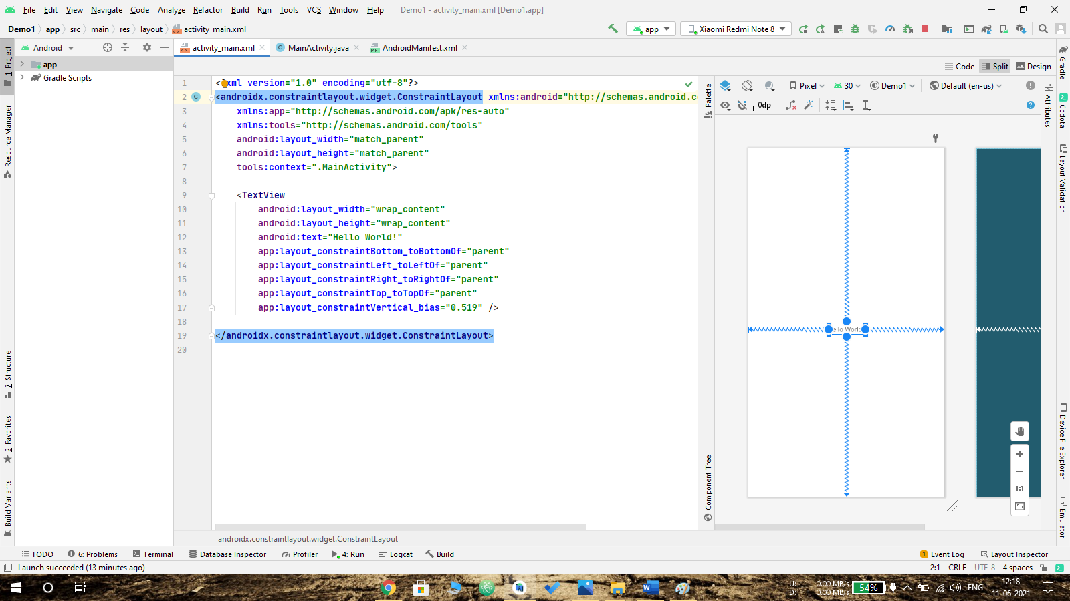

Activity_main.xml:



Output:

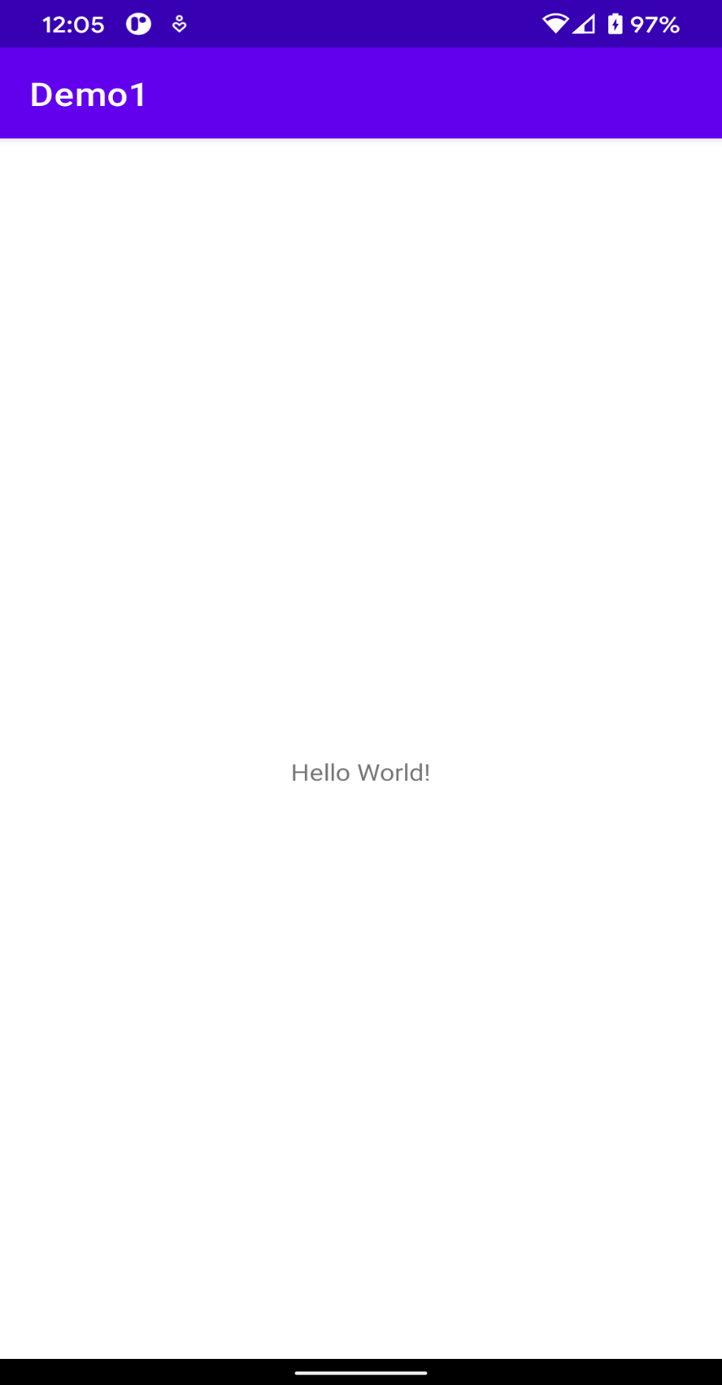

**2 – NormalCalc:**

In this two Inputs required for the operation. In this we can do 4 operation Summation, Subtraction, Division, Multiplication.

In this we get the data from user input like:

**Number1 = editText.getText().toString();**

And after operation performed, we have to set the data to the TextView like:

**textView.setText(“Text”);**

**Code:**

Main Activity:

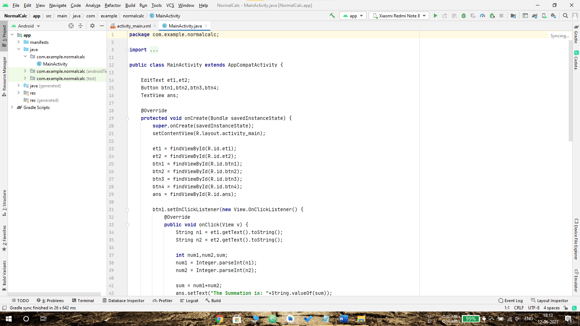

Activity_main.xml:

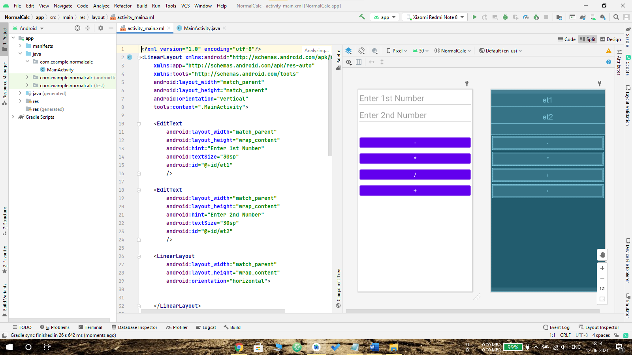

Output:

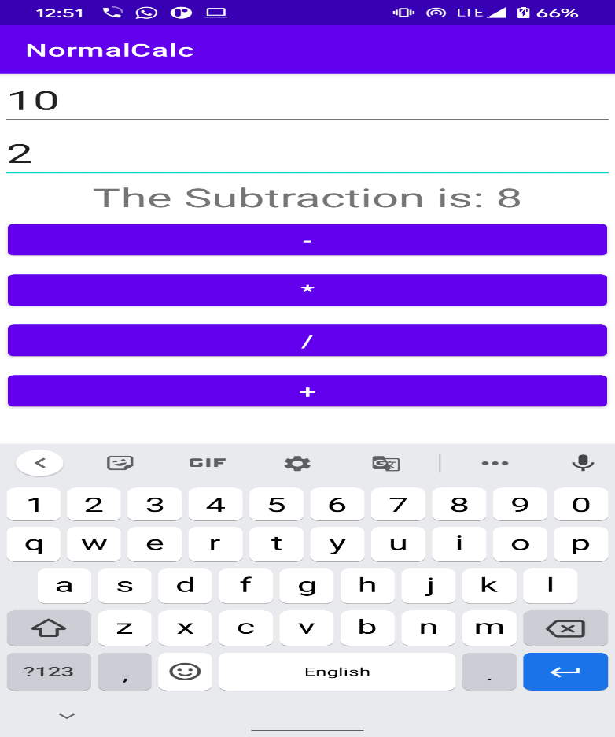 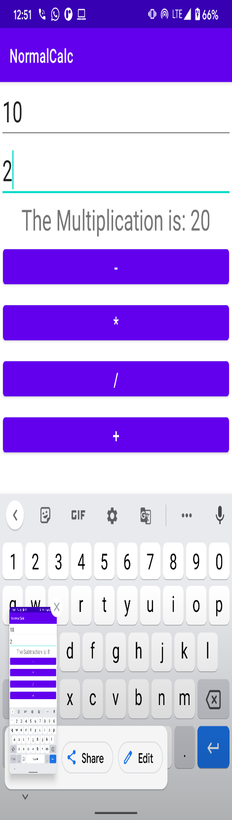

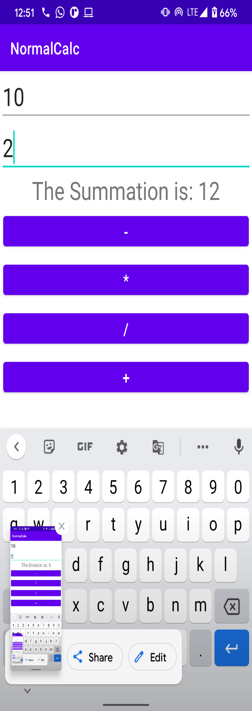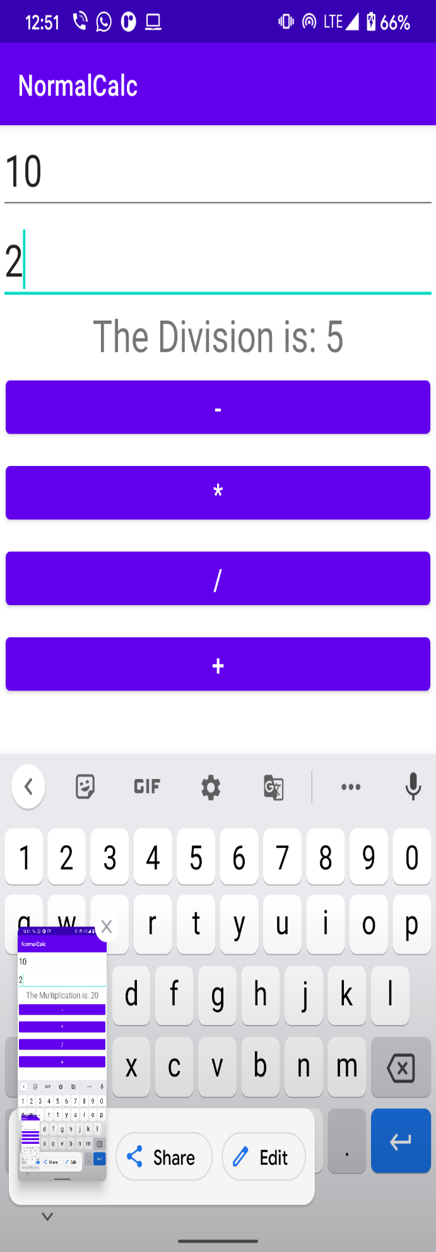

**2.1 – Summation:**

**Code:**

Main Activity:

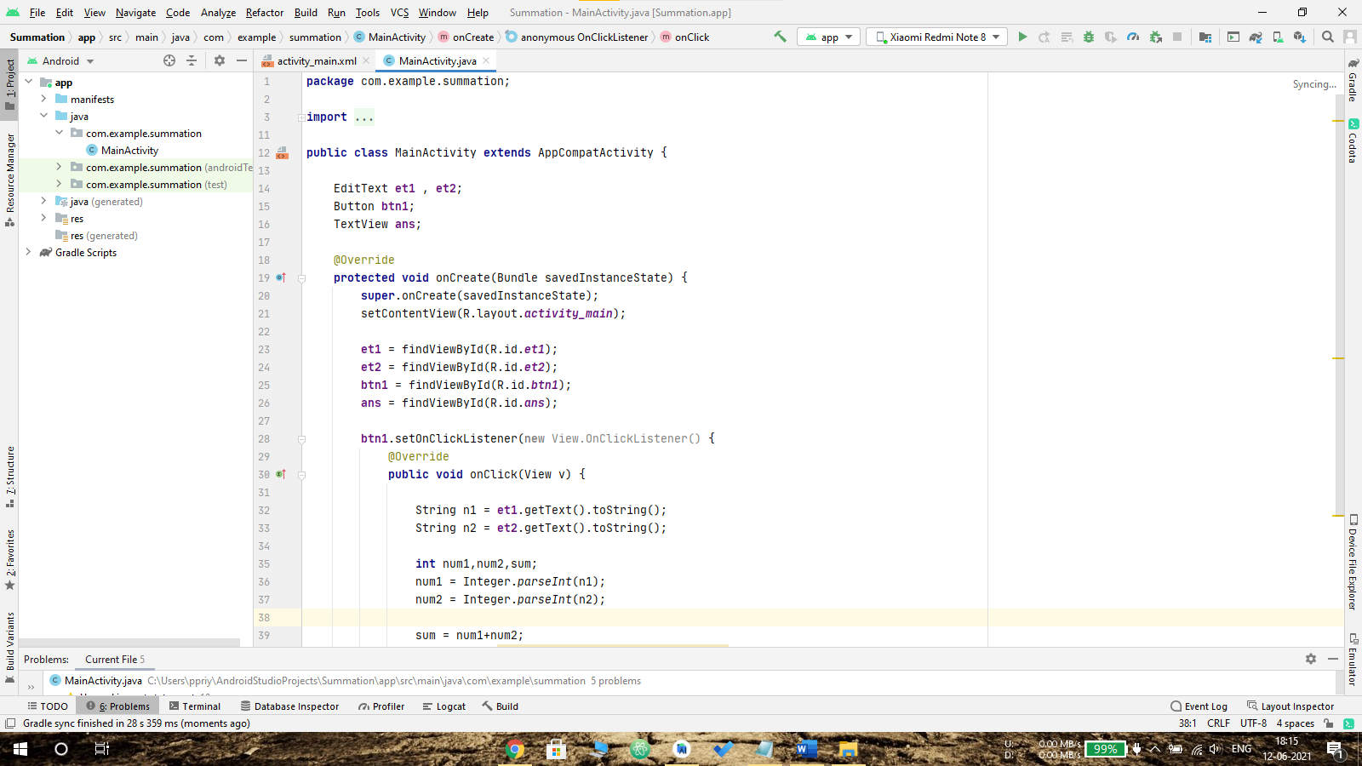

Activity_main.xml:

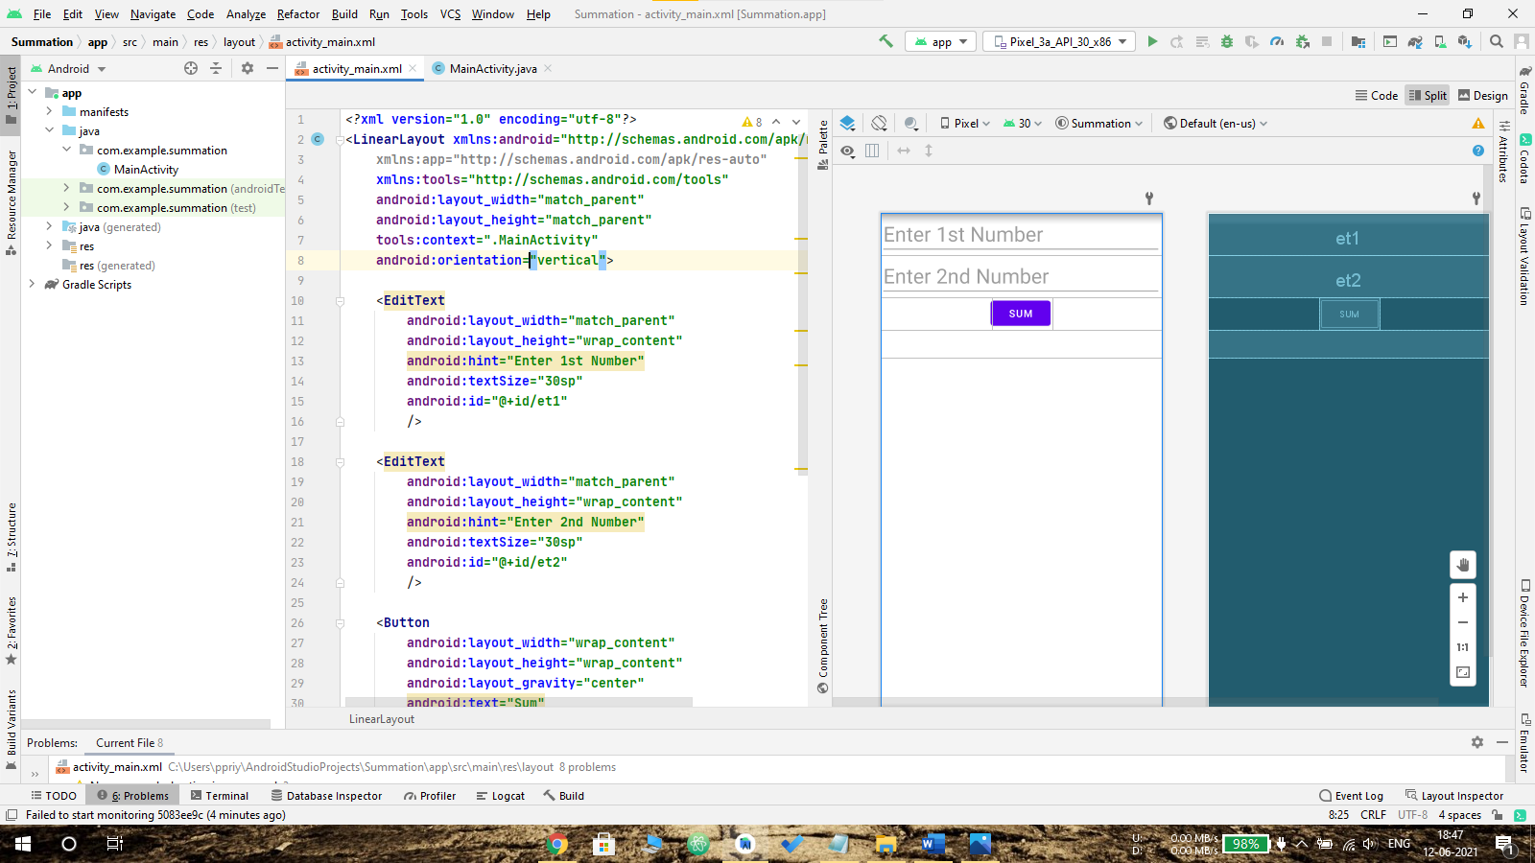

Output:

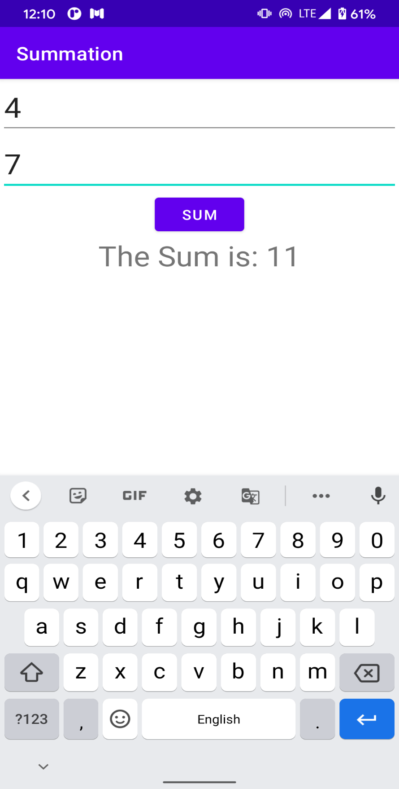

**3 - Intent:**

Android app may contain one or more screens. Intent basically used to provide navigation from one activity to other activity. Intents allow us to interact with components from the same applications as well other third-party applications

We can use intent like this:

**Intent intent = new Intent(context,navigationActivity.class);**

**startActivity(intent);**

**Code:**

Main Activity:

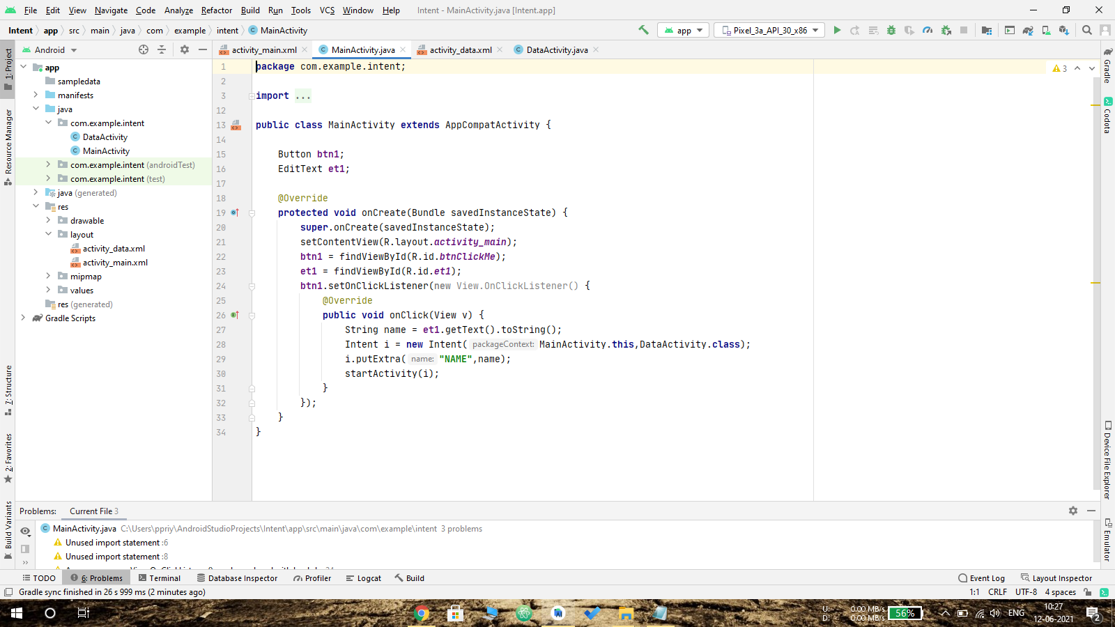

Activity_main.xml:

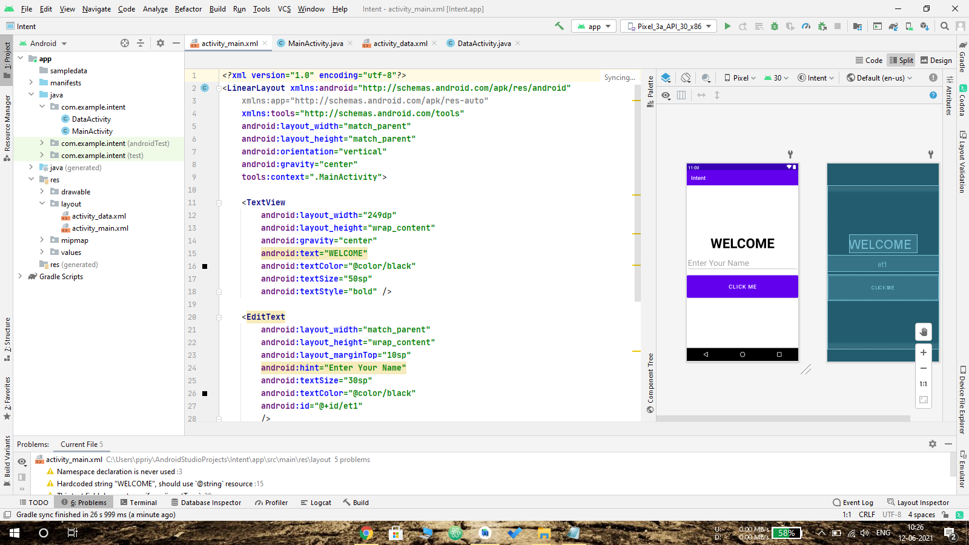

Output:

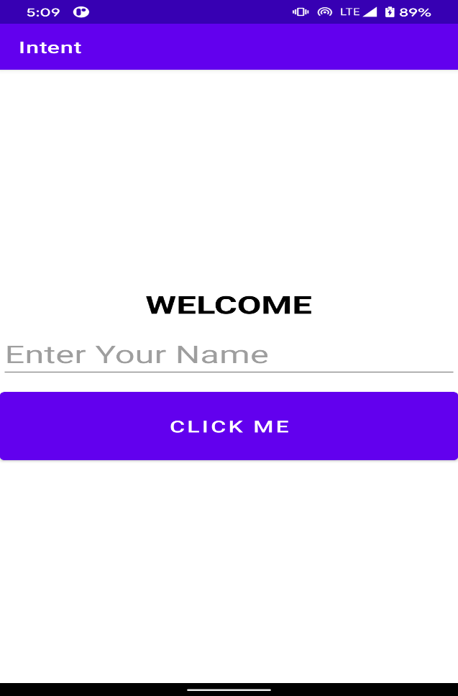

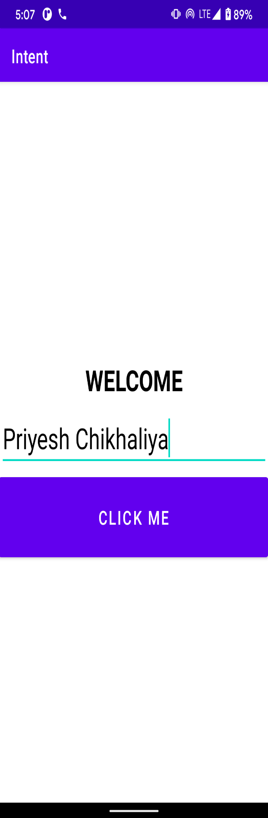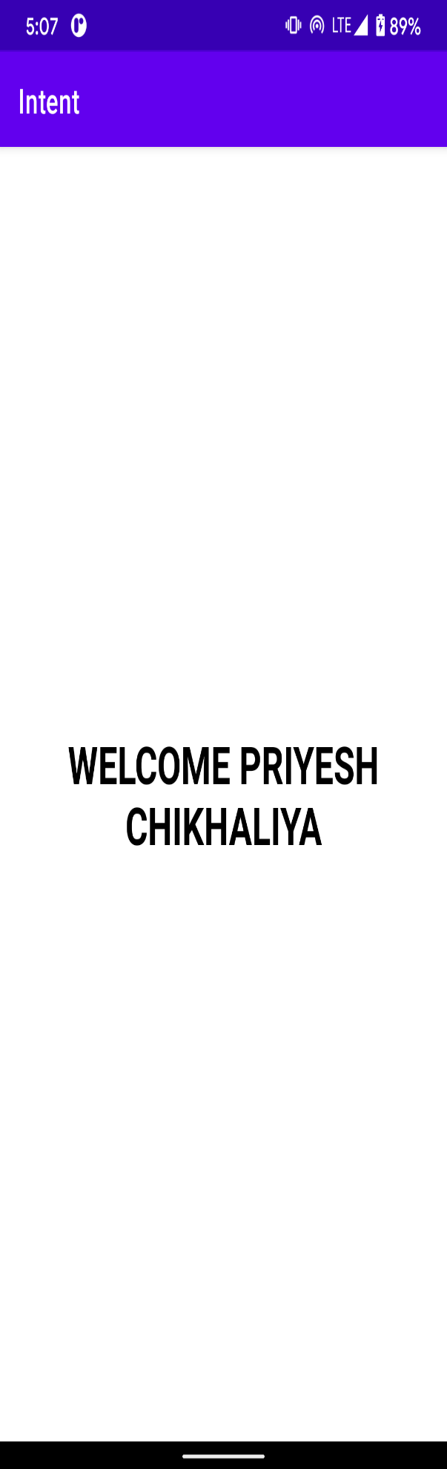

**3.1 – Activity life cycle:**

There is a sequence of callback methods that start up an activity and a sequence of callback methods that tear down an activity as shown in the below Activity life cycle.

Main activity:

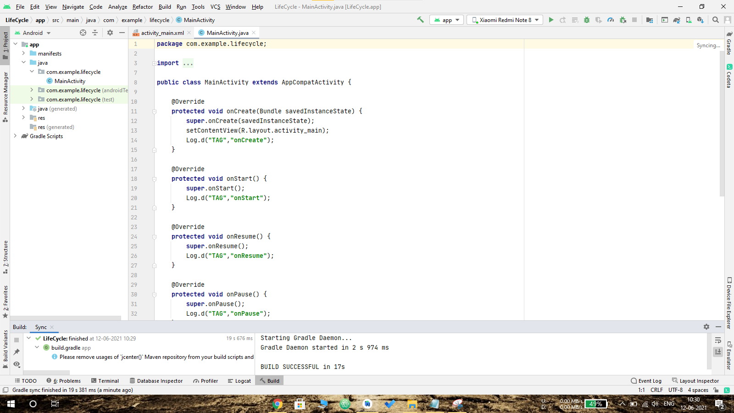

Activity_main.xml:

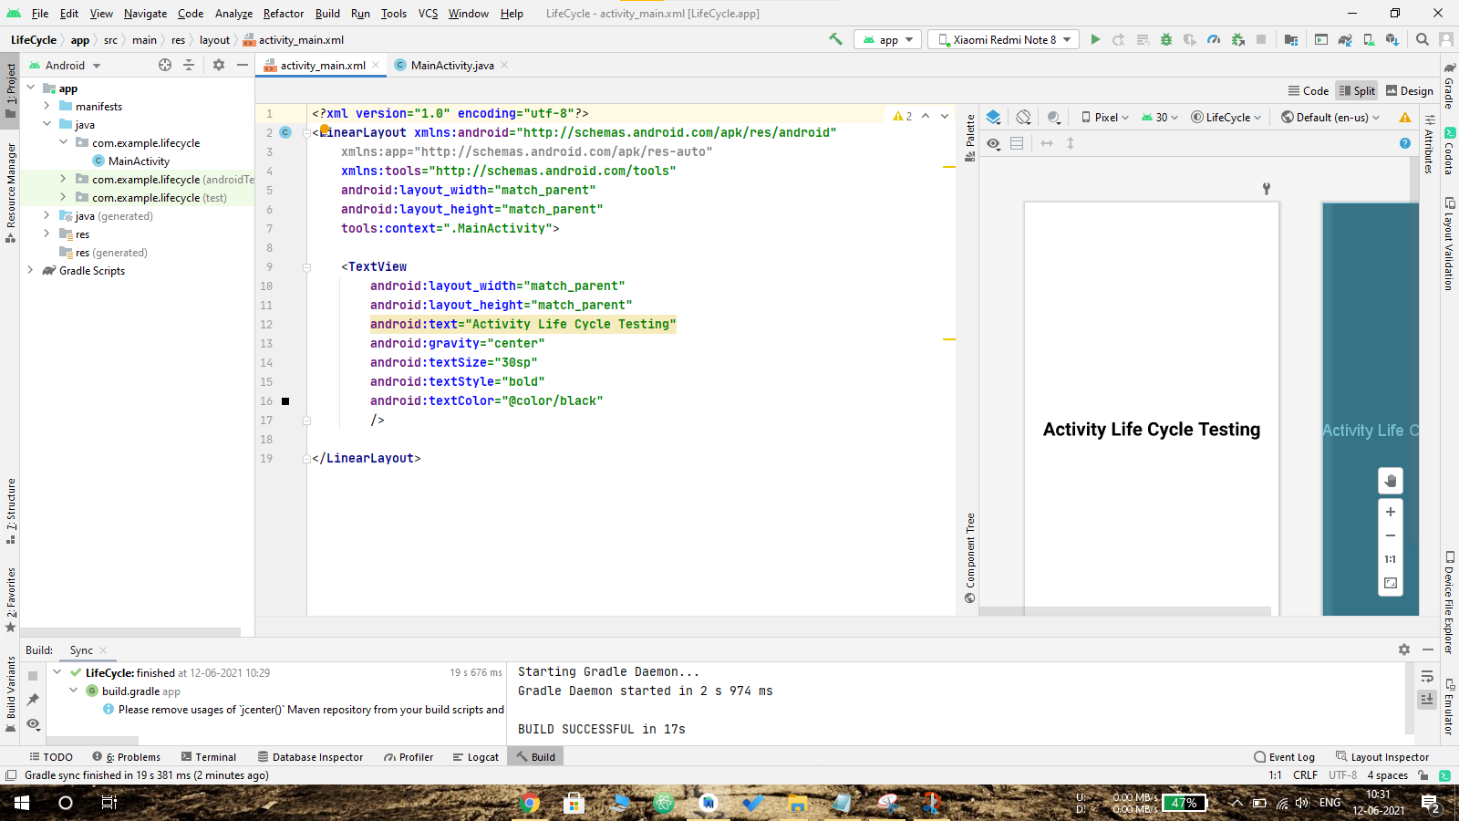

Logcat:

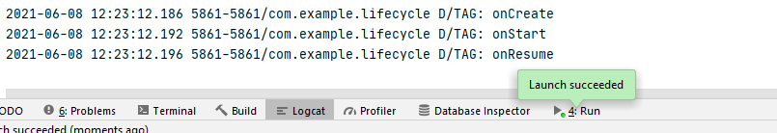

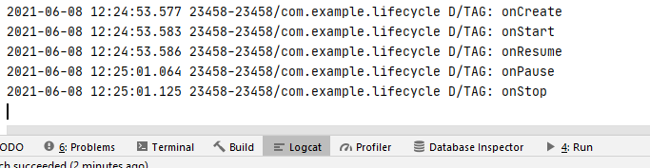

**4 - MyRegistration**

In this app it takes inputs like registration details and that details send to other activity called data activity and set that data to text view using **setText()** Method.

**Code:**

Main Activity:

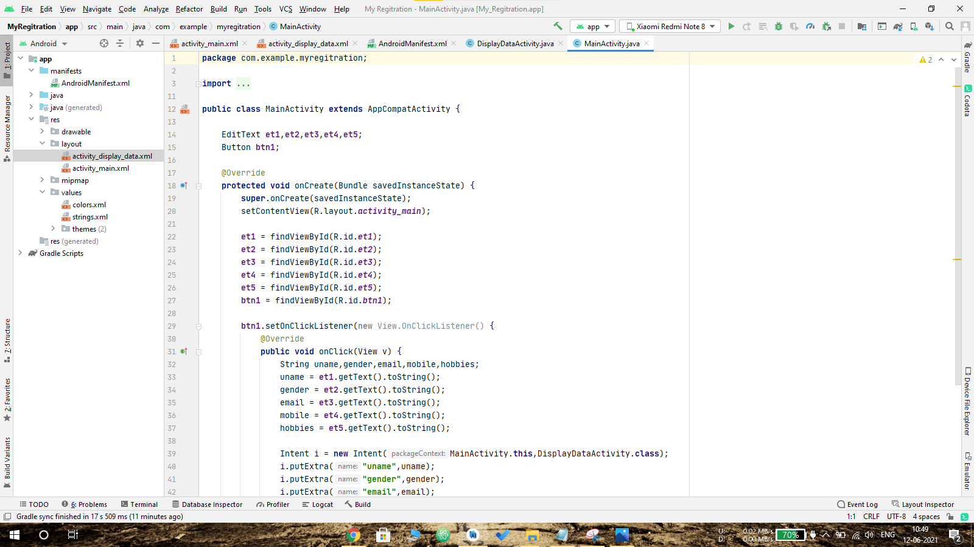

Activity_main.xml:

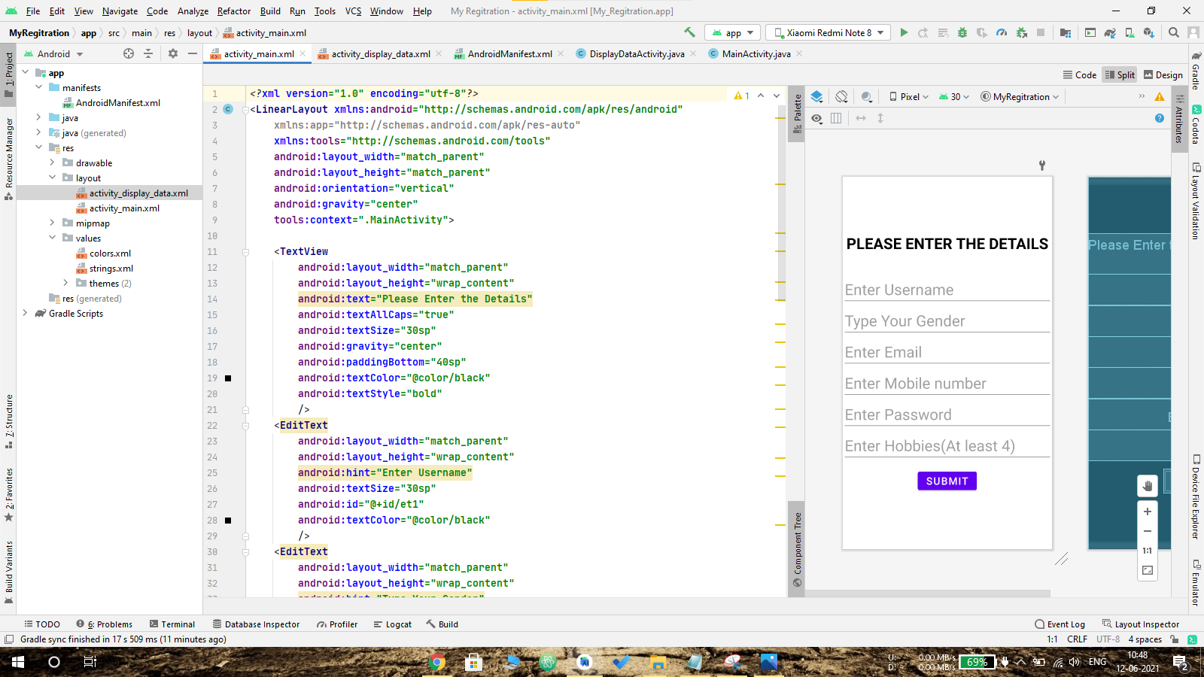

Output:

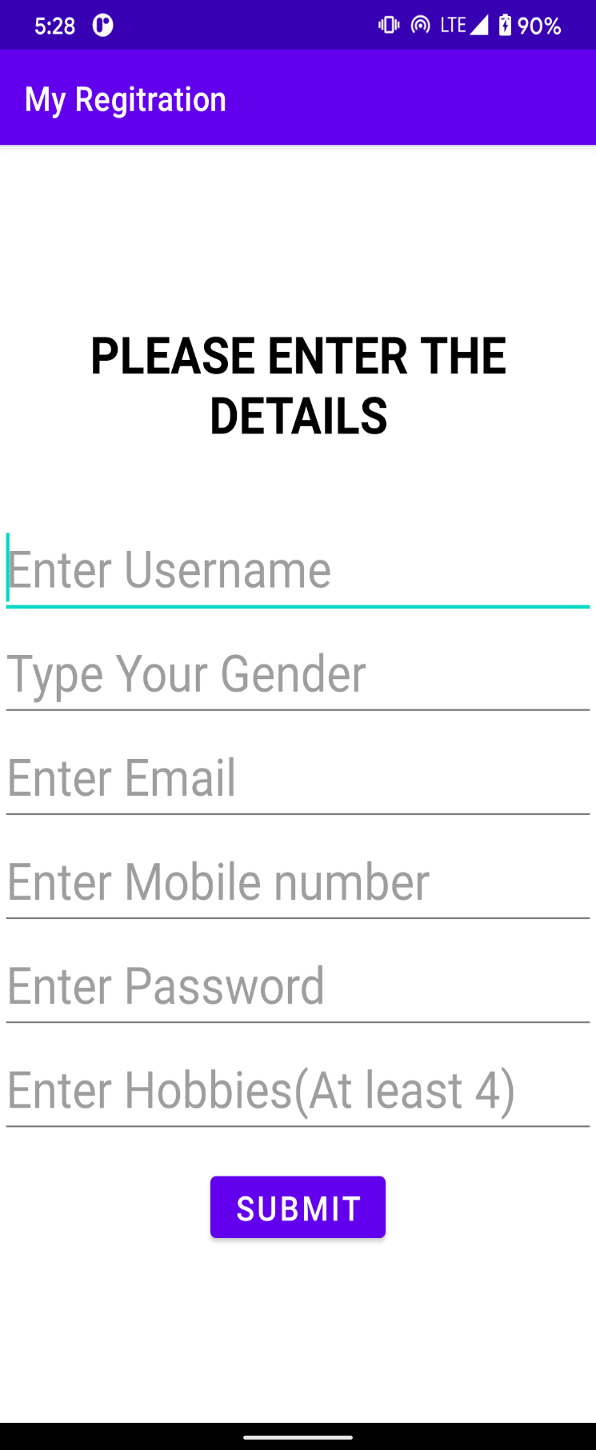

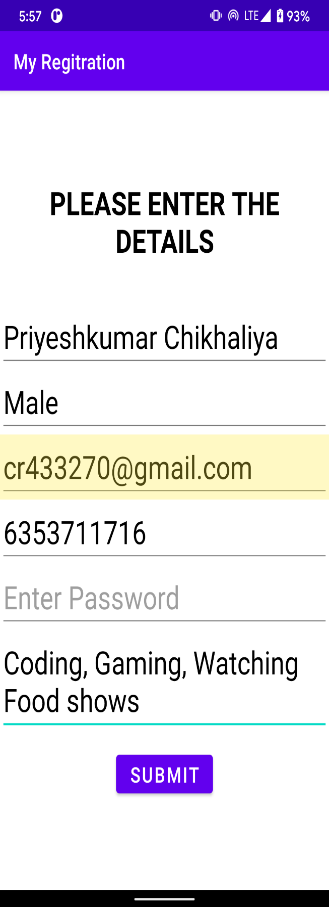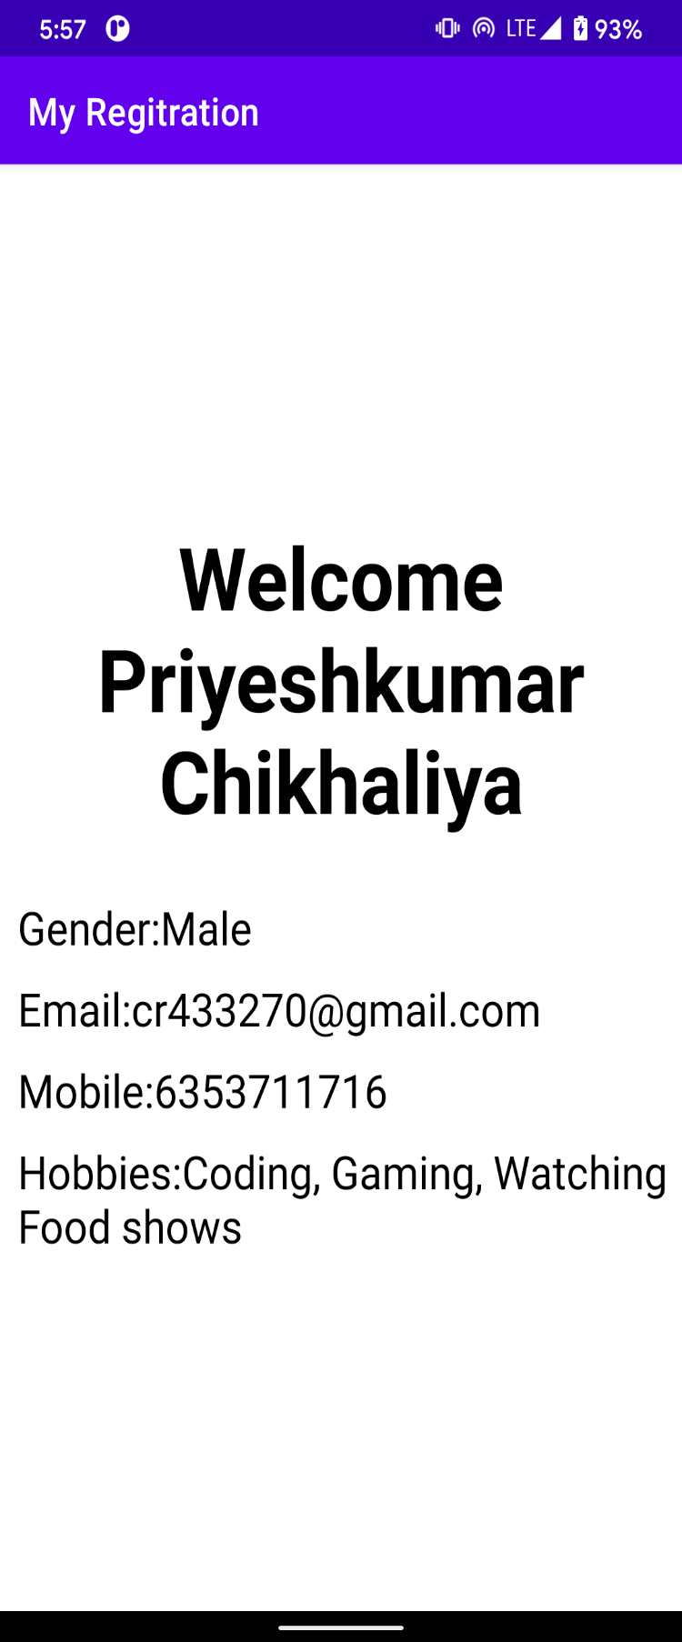

**5 -Splash Screen:**

Android splash screen are normally used to show user some kind of progress before the app’s main screen. Some people use splash screen just to show their app / company logo for a couple of second (Mostly 3 to 4 seconds).

**Code:**

Main activity:

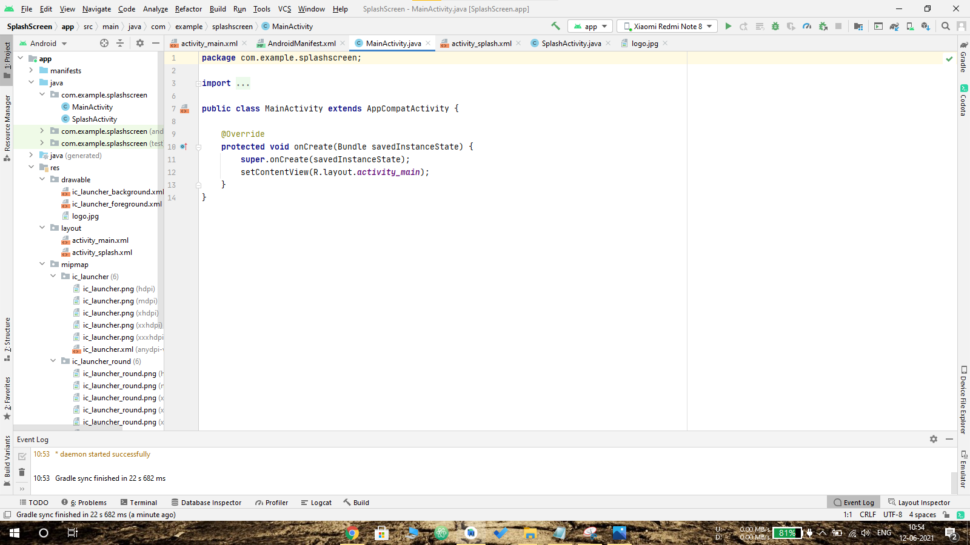

Activity_main.xml:

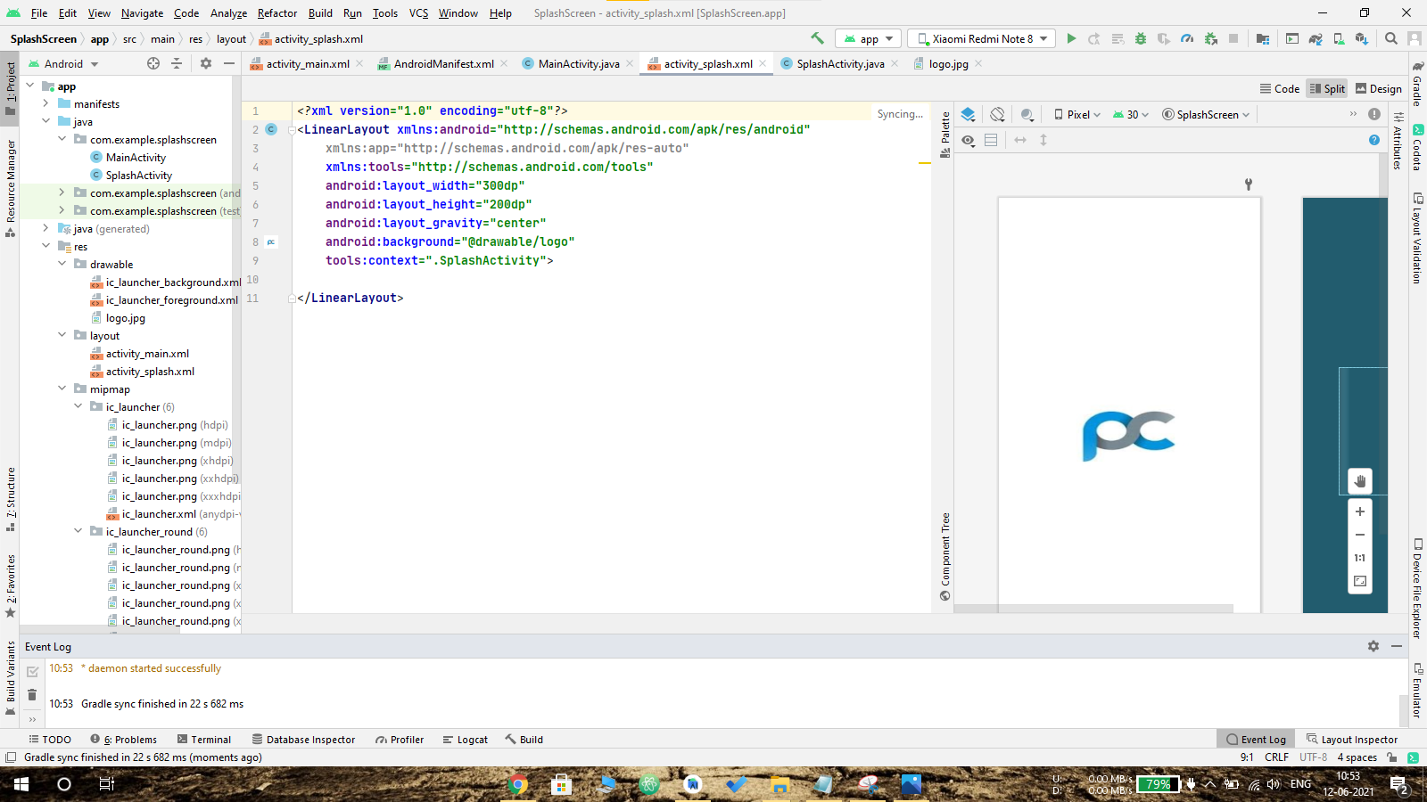

AndroidManifest.xml:

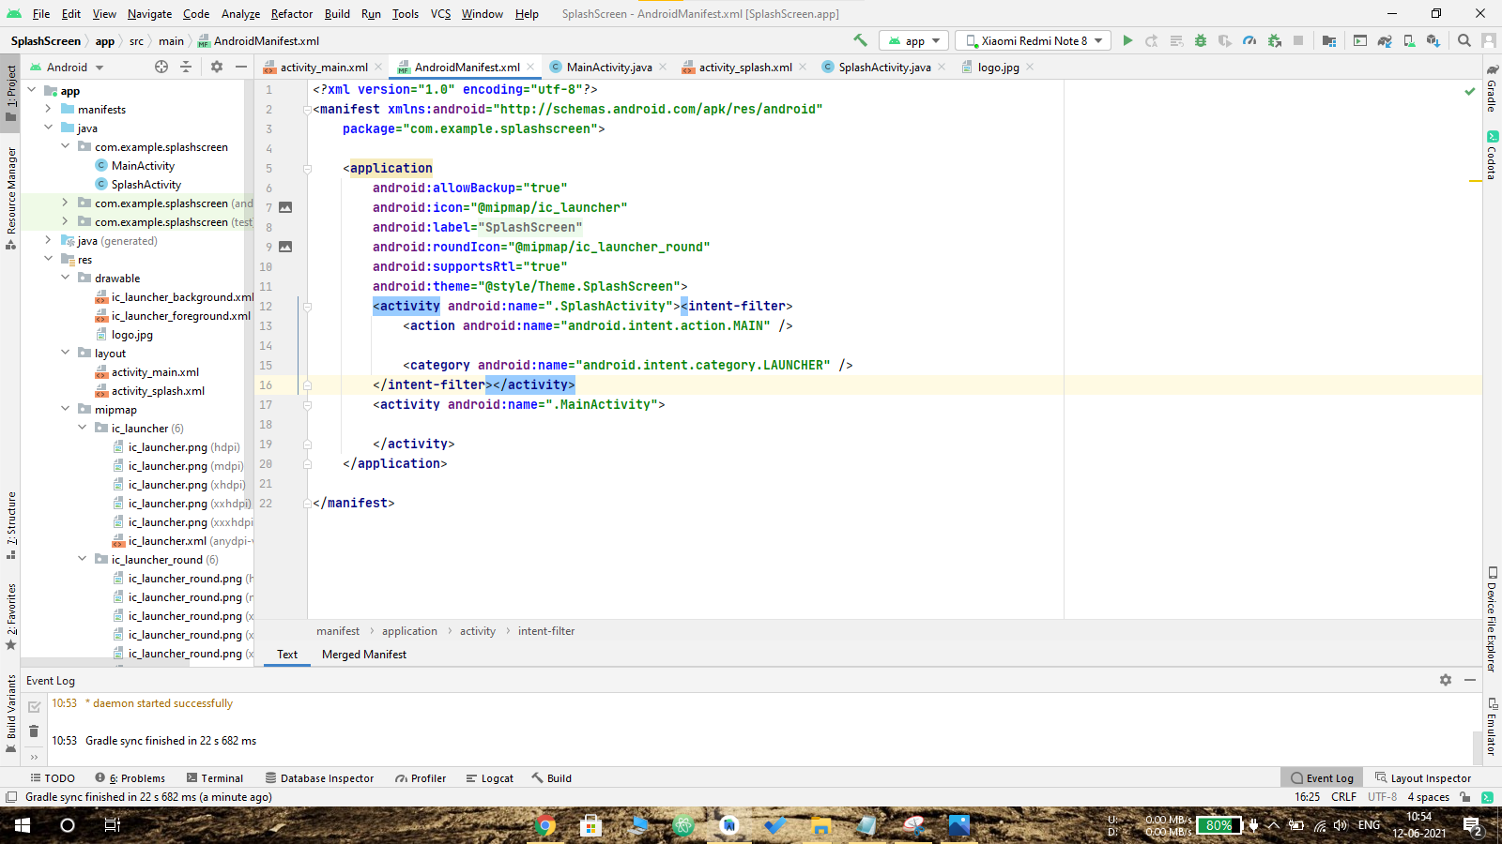

Output:

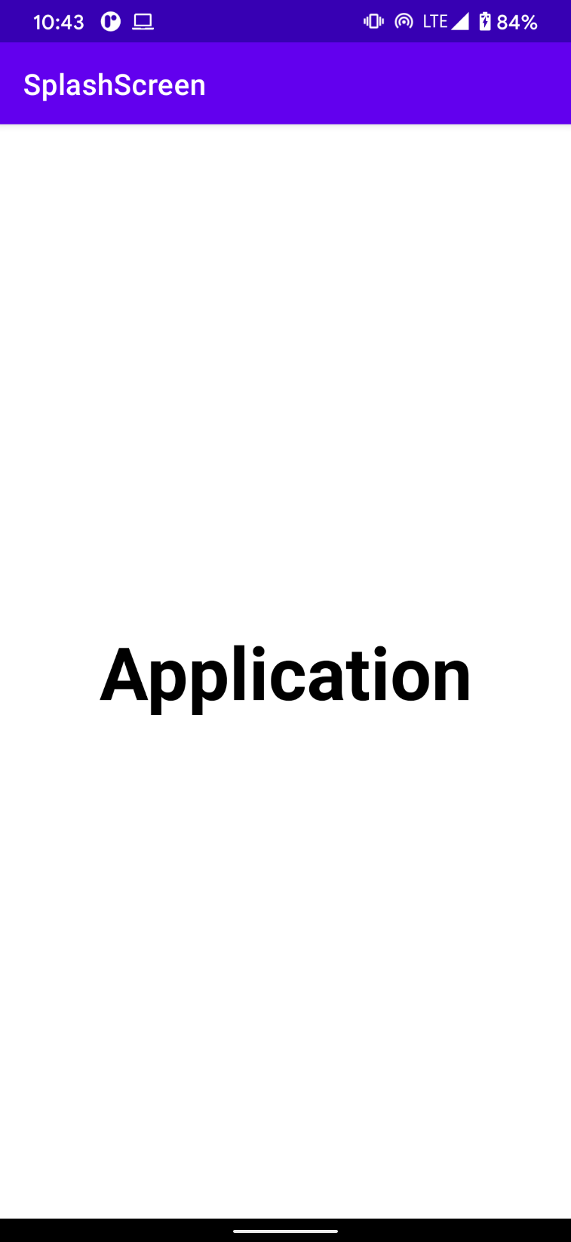 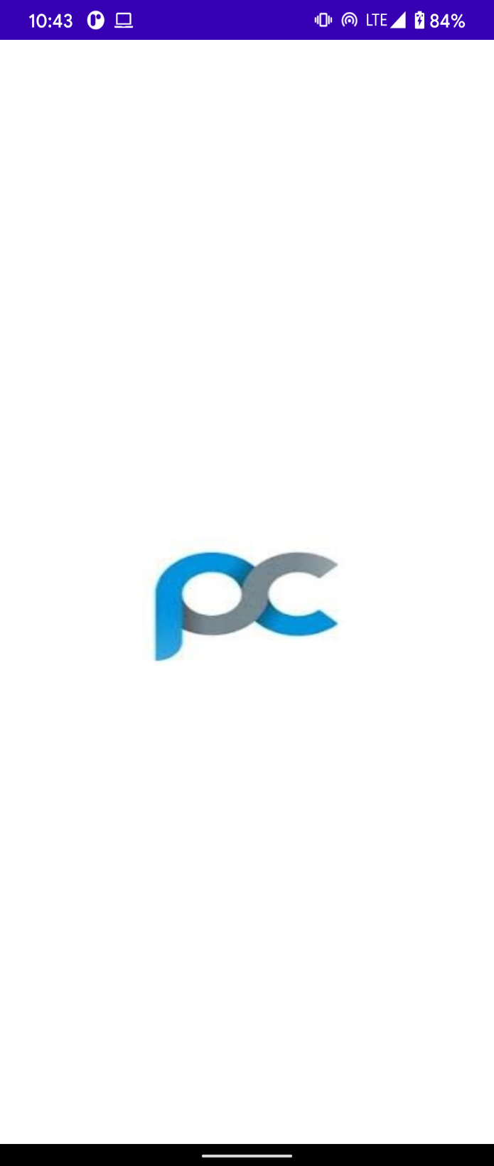

**5.1 -Three Splash Screen:**

**Main activity:**

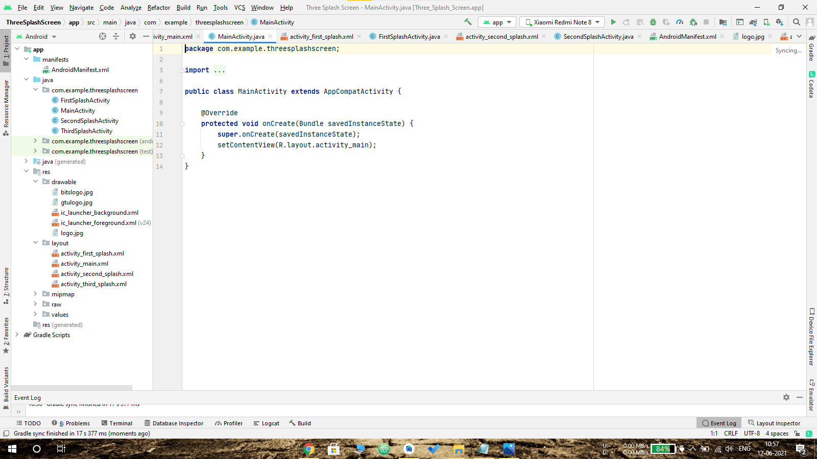

**Activity_first_splash.xml:**

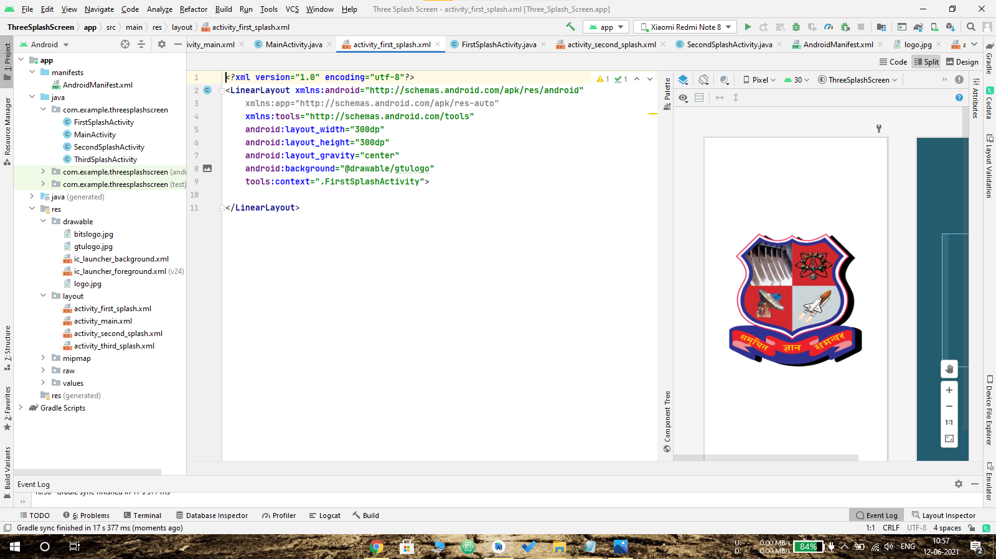

**Activity_second_splash.xml:**

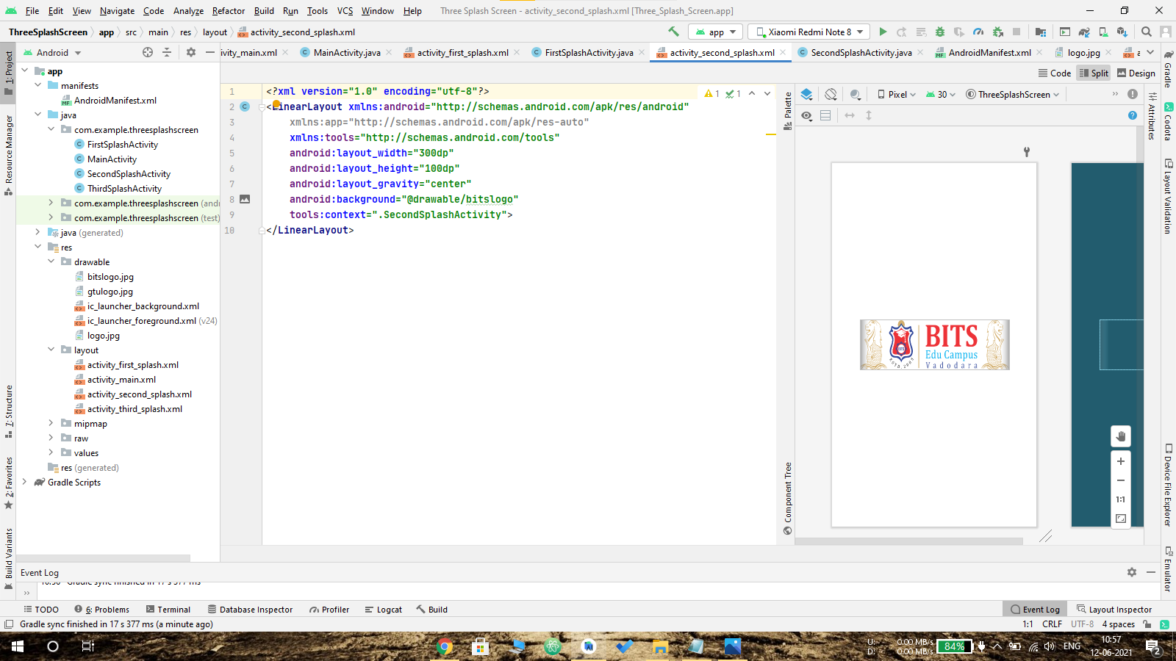

**Activity_third_splash.xml:**

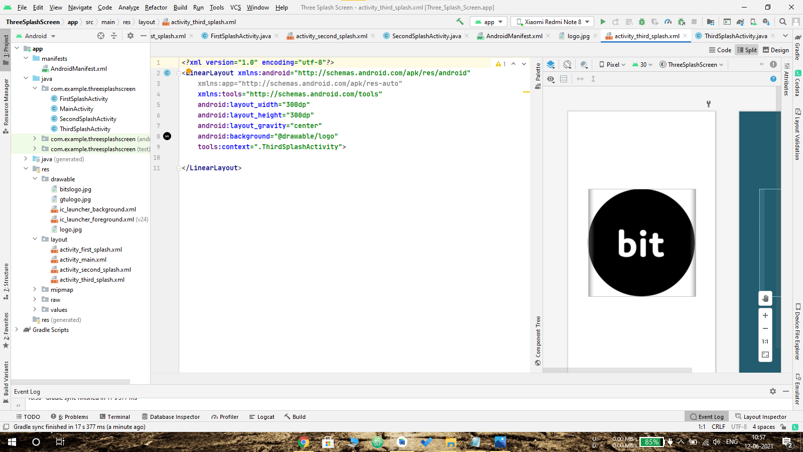

**Output:**

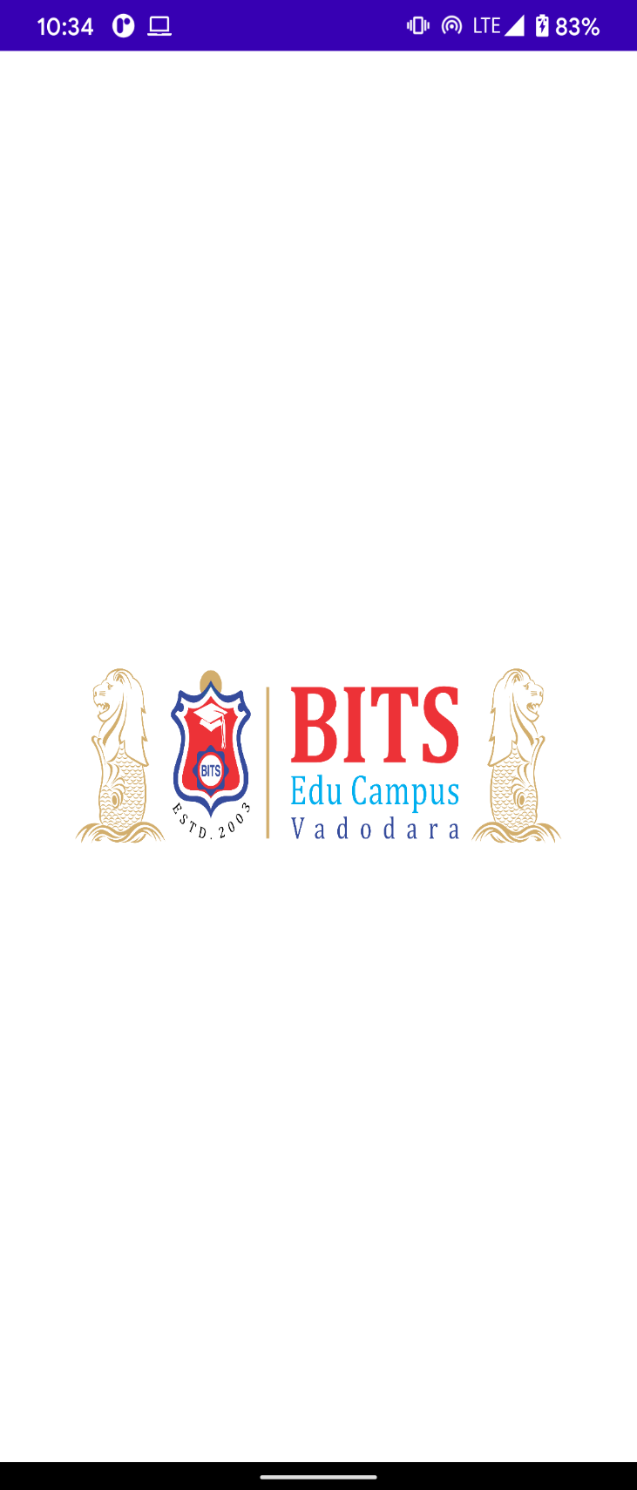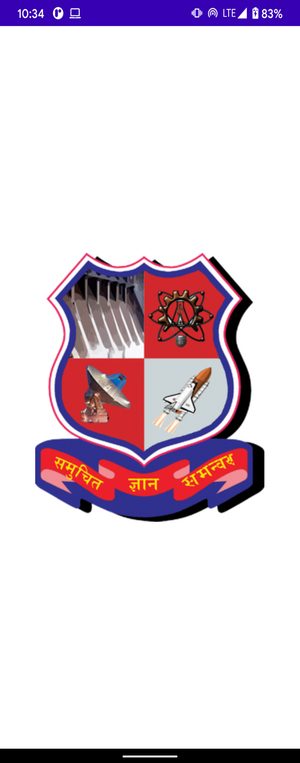

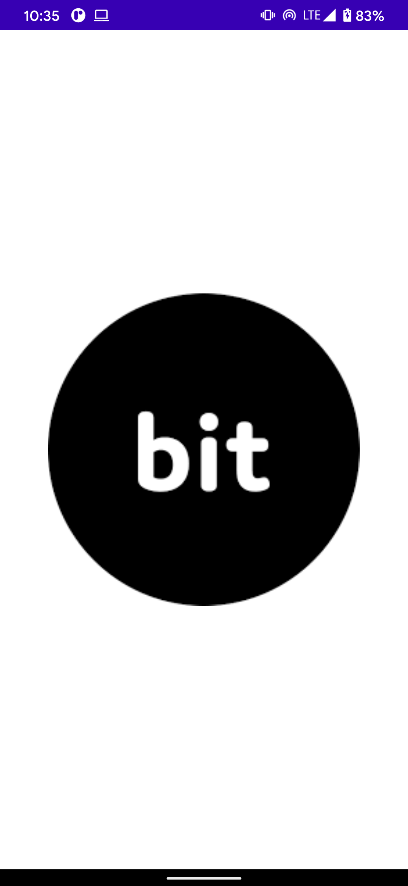

**6 - List View-Master:**

The list items are automatically inserted to the list using an Adapter that pulls content from a source such as an array or database.

**android:id, android:divider , android:dividerHeight** are the properties of List View.

An adapter actually bridges between UI components and the data source that fill data into UI Component. Adapter holds the data and send the data to adapter view.

We can use the adapter like:

**ArrayAdapter adapter = new ArrayAdapter(context, R.layout.ListView, StringArray);**

**Code:**

Main activity:

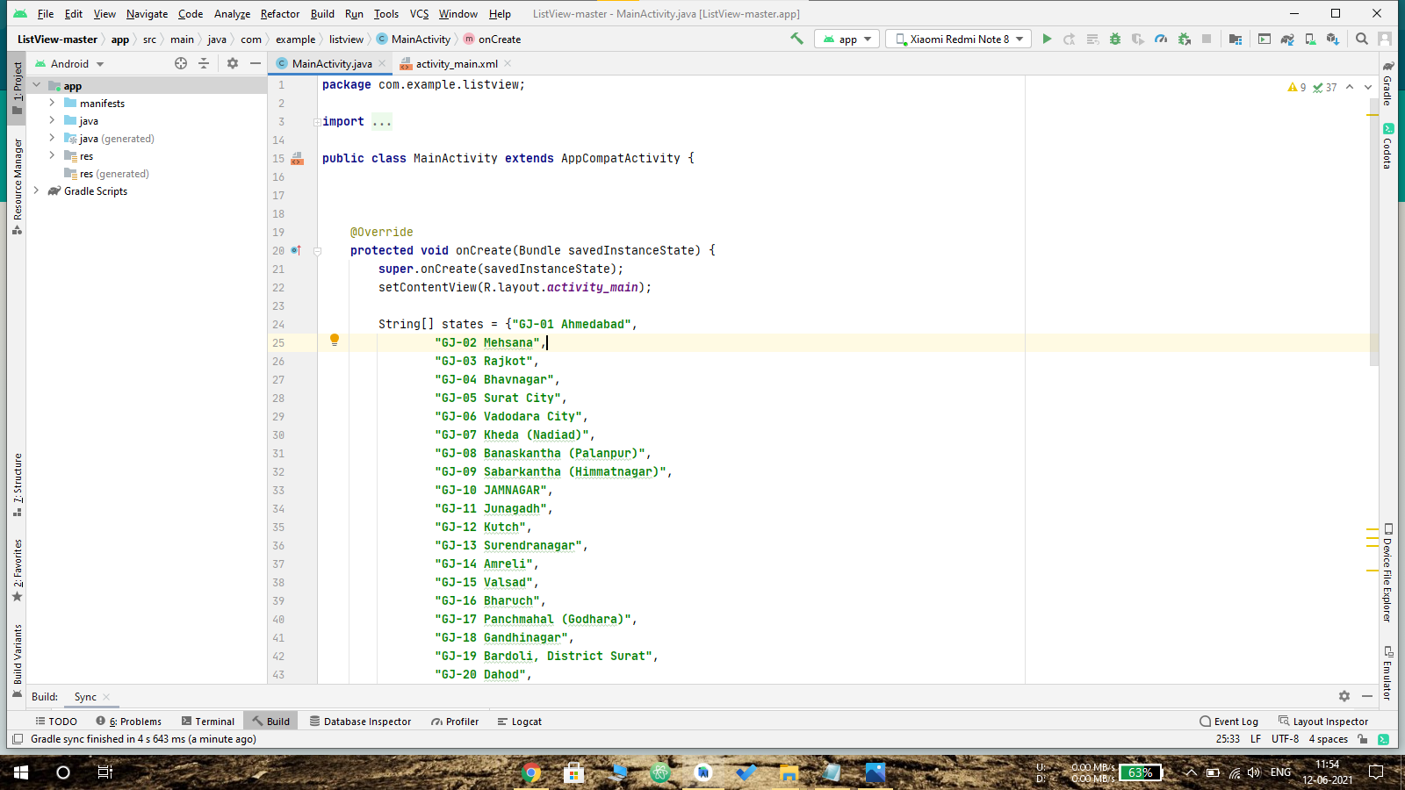

Activity_main.xml:

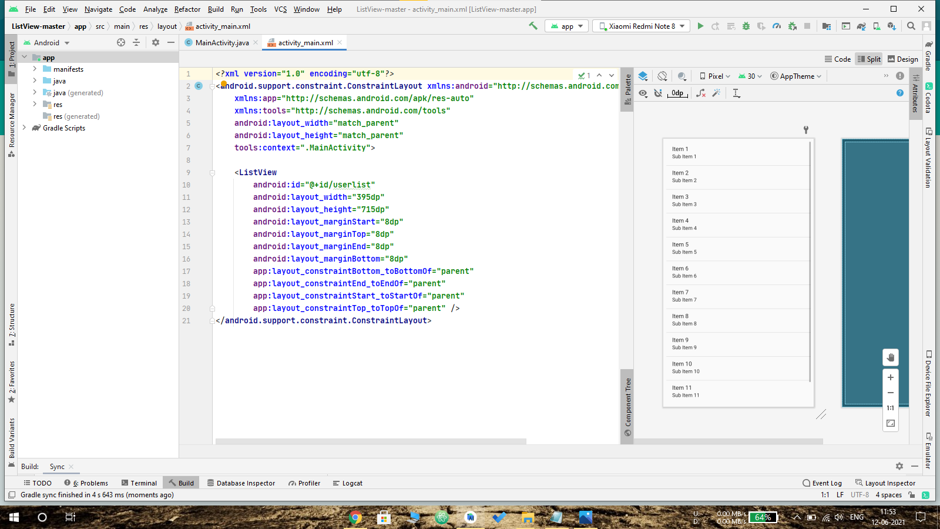

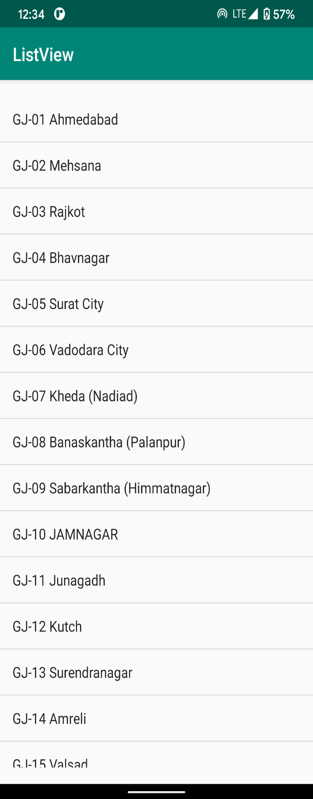Output:

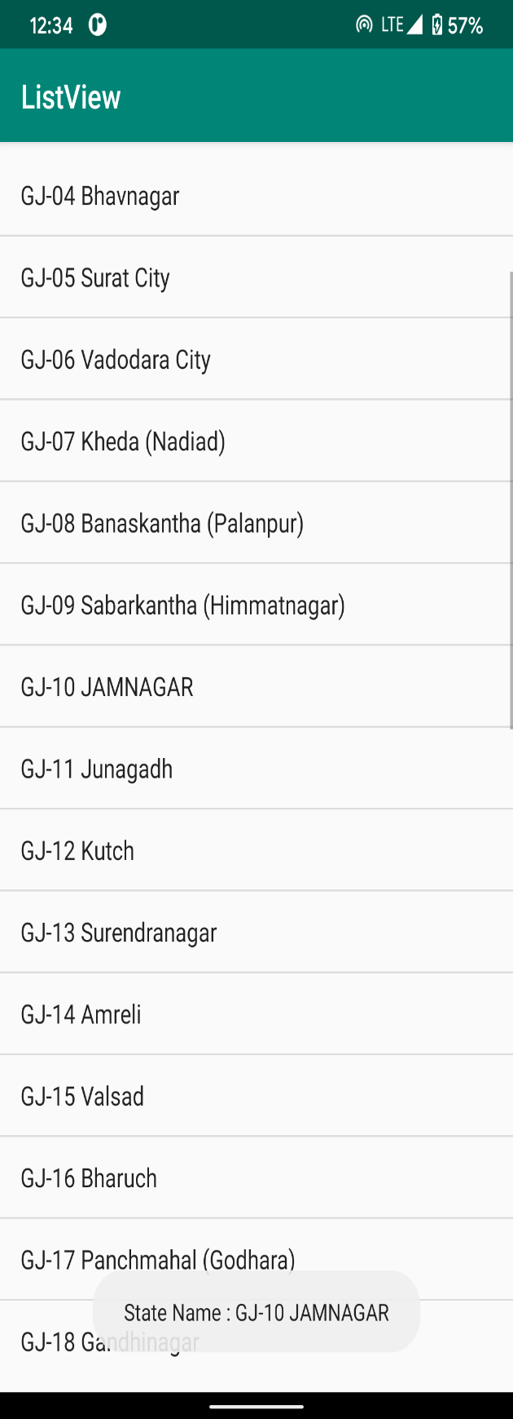

**6.1 -Custom view list:**

Main activity:

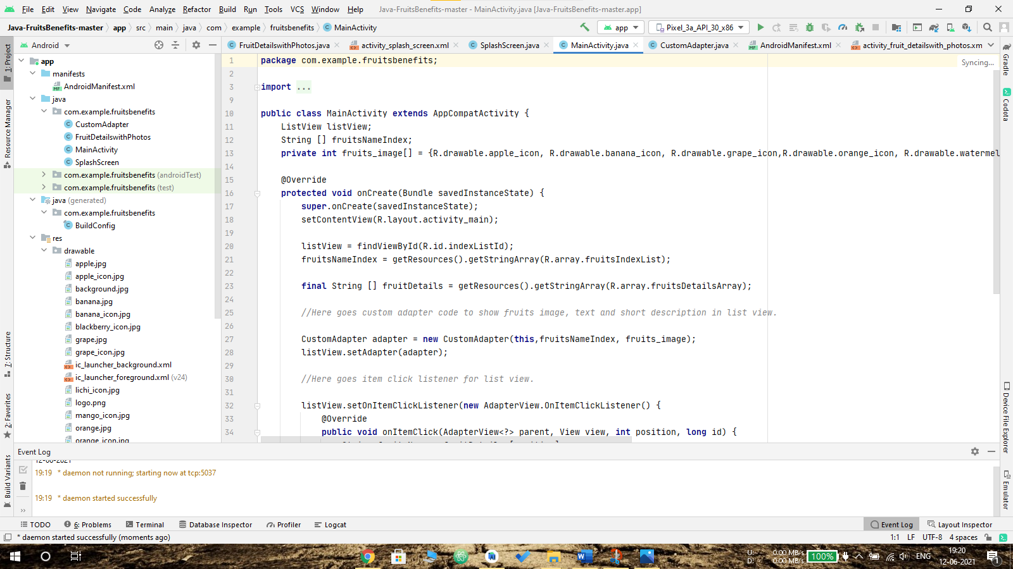

Activity_main.xml:

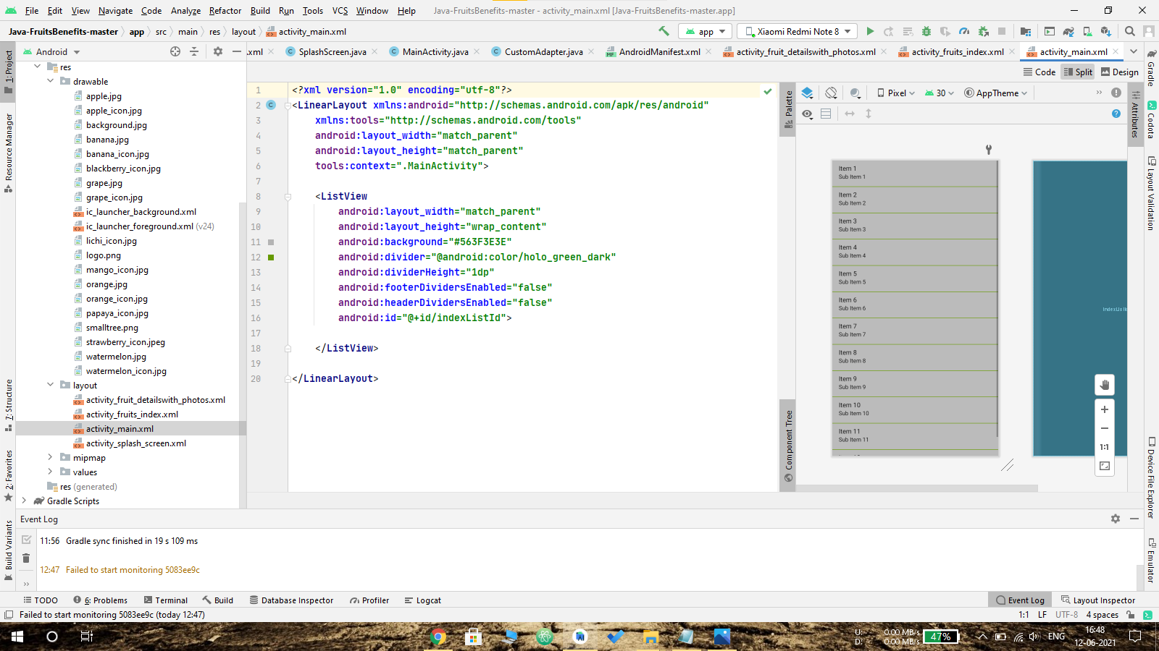

Activity_splash_screen.xml:

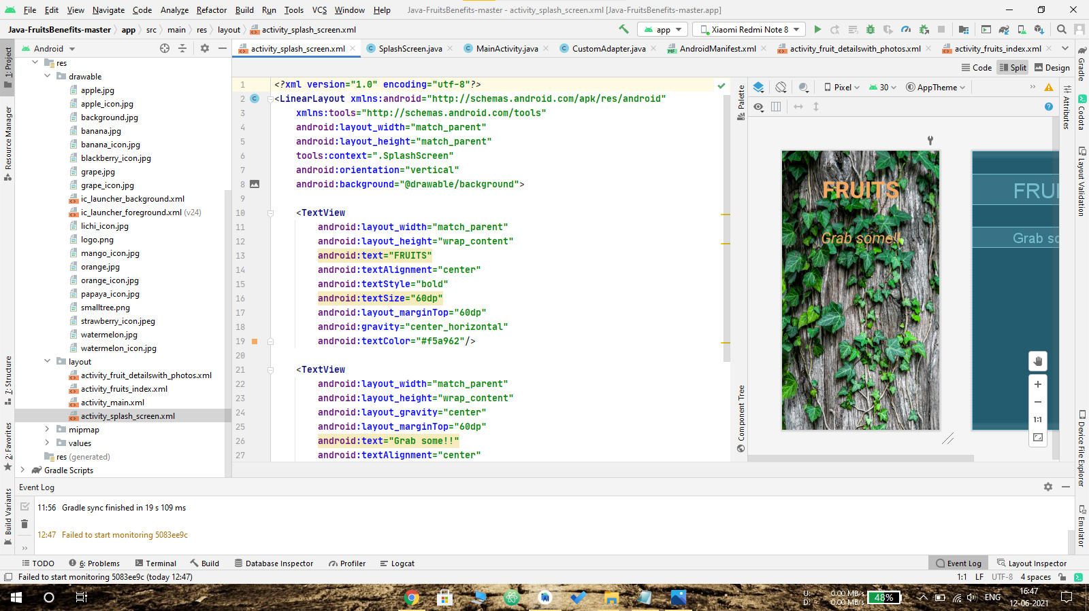

Activity_friuits_details_with_photos.xml:

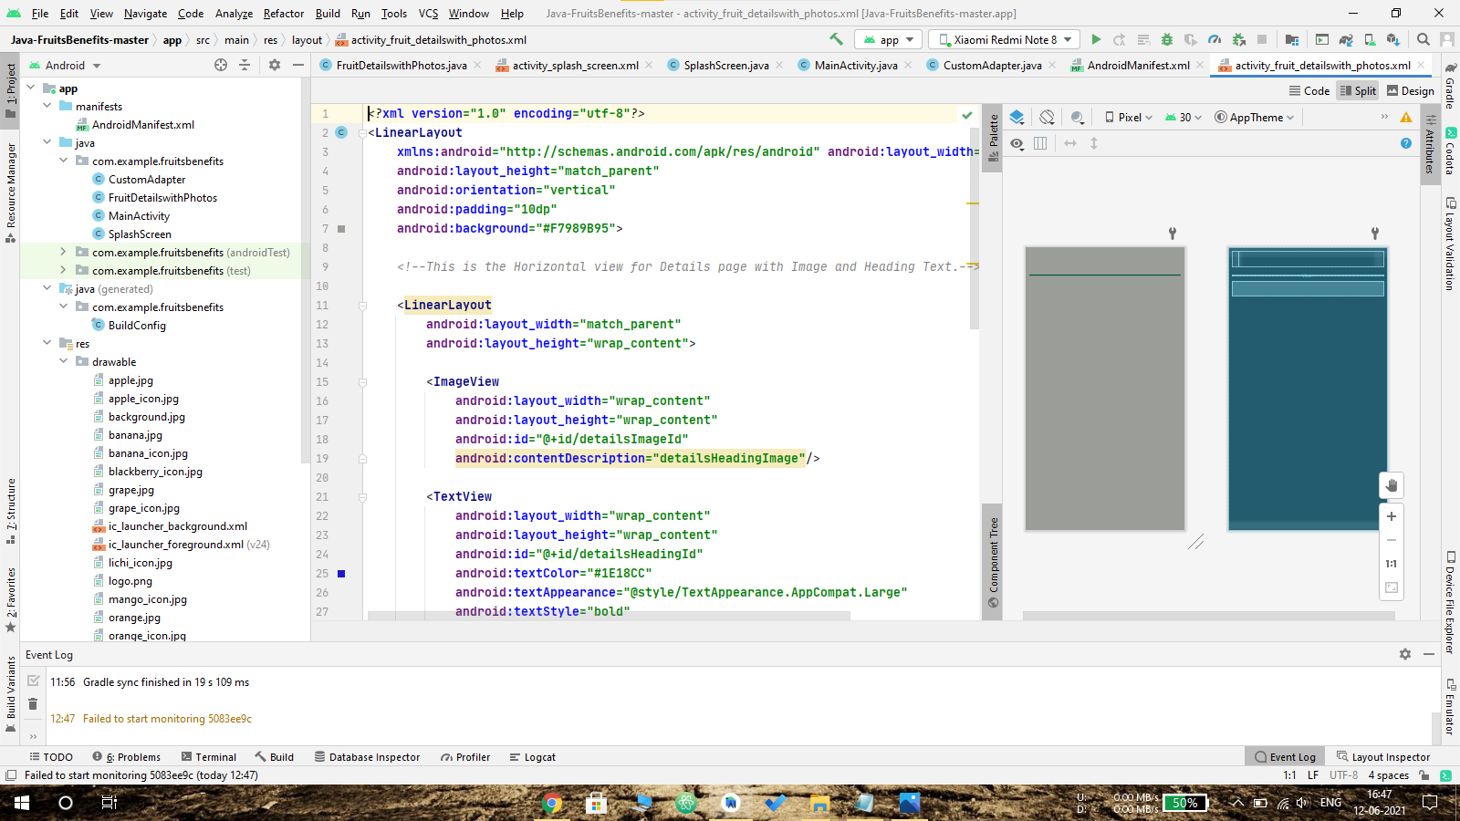

Output:

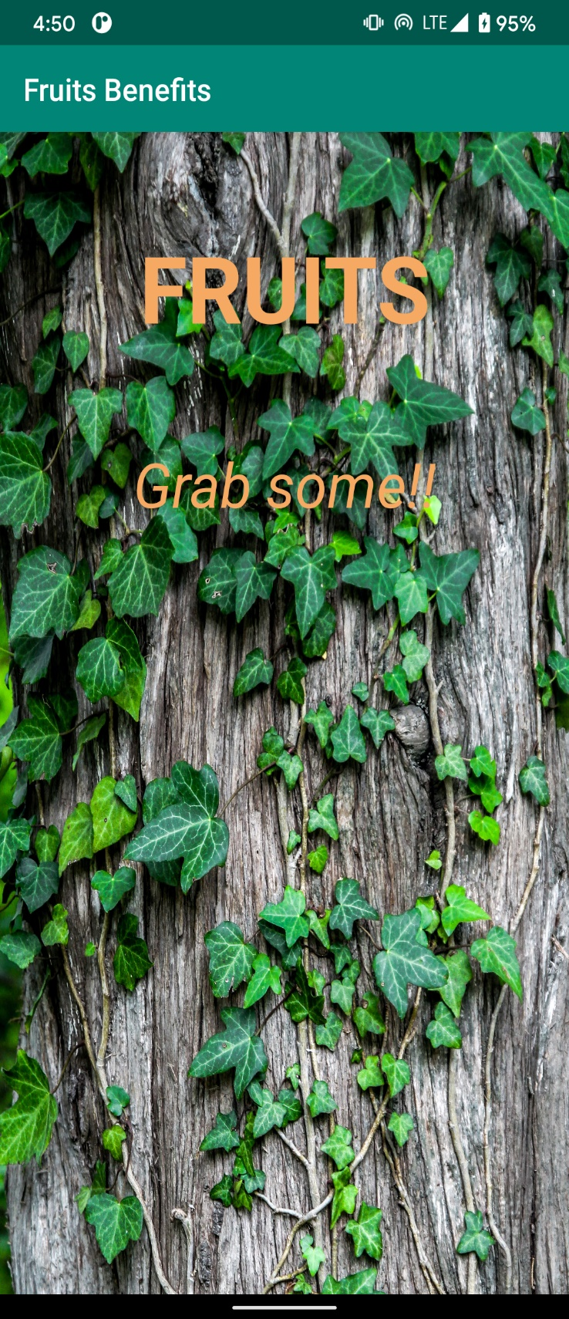

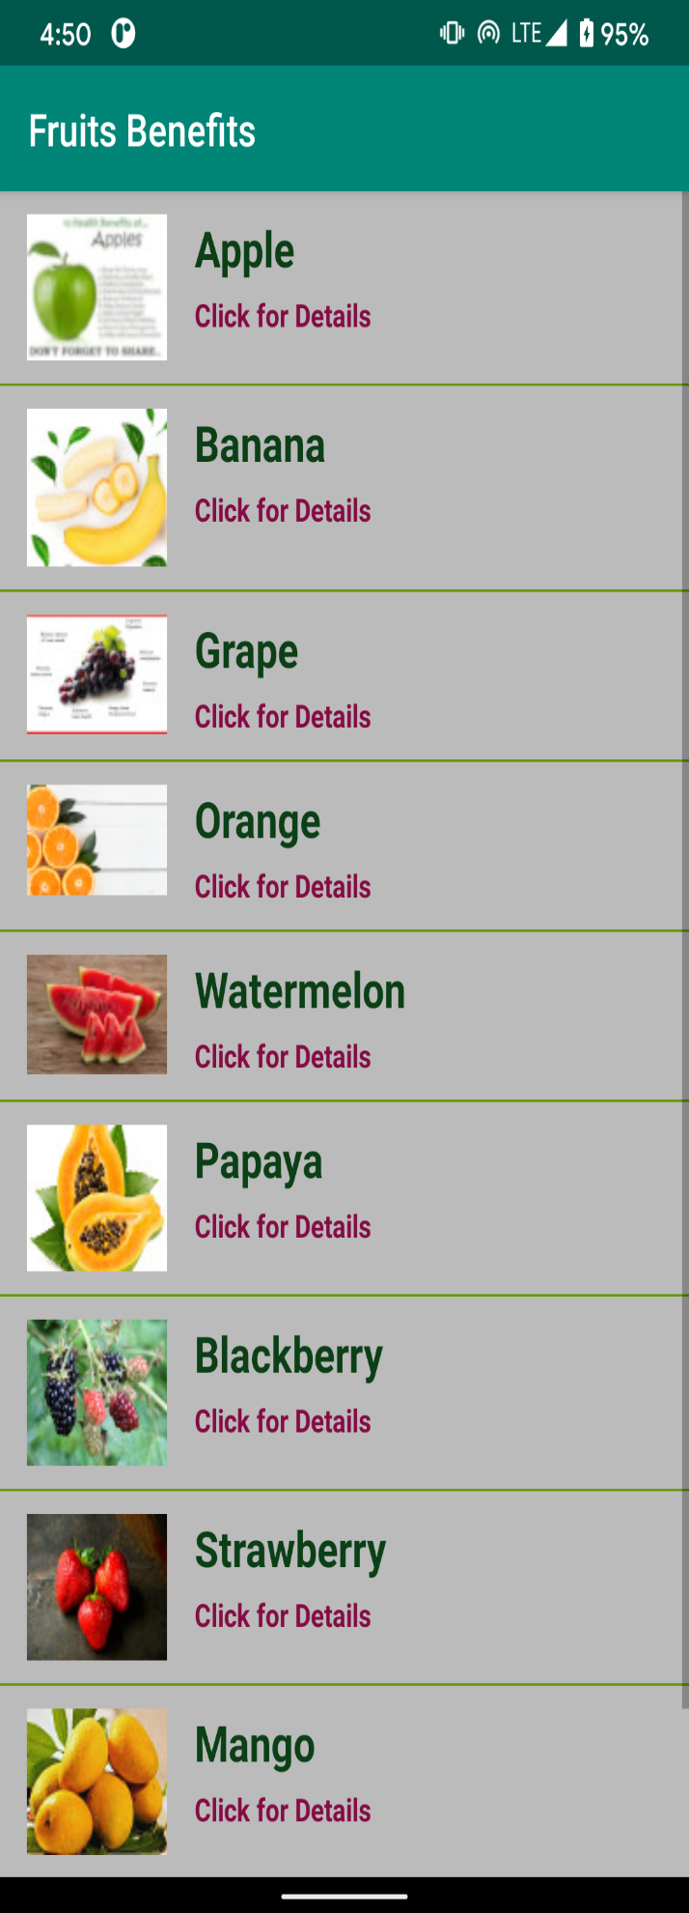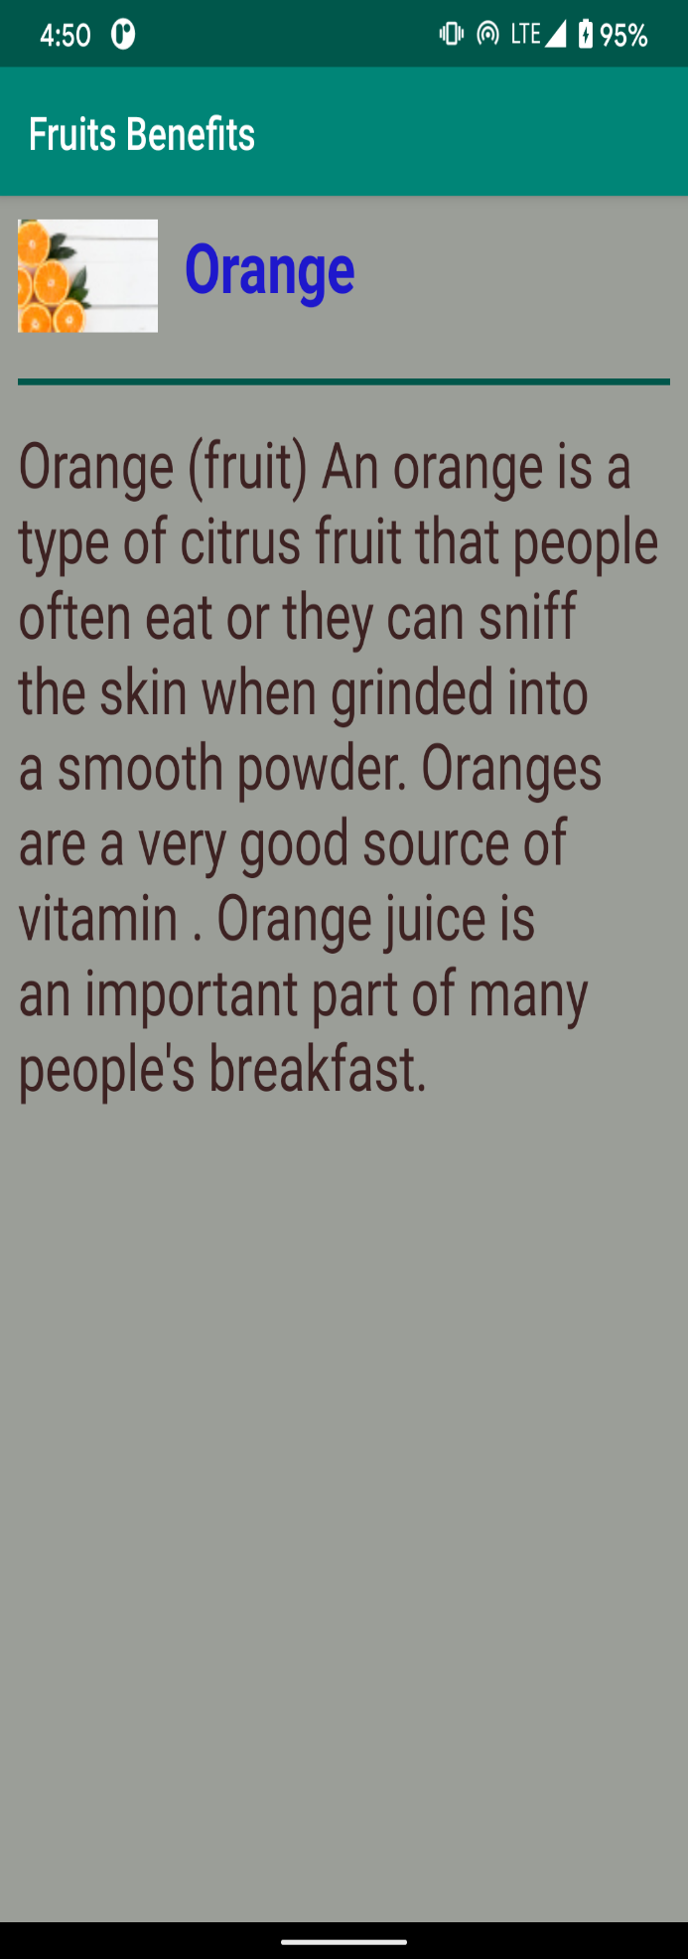

**7 - Shared Preferences:**

Using Shared Preferences, we can store the data on local device for temporary purpose if user clear the data of app, then the stored data of shared preferences are removed and users have to login again.

Using Shared Preferences, we can make user stay logged IN in the application.

**Code:**

Main activity:

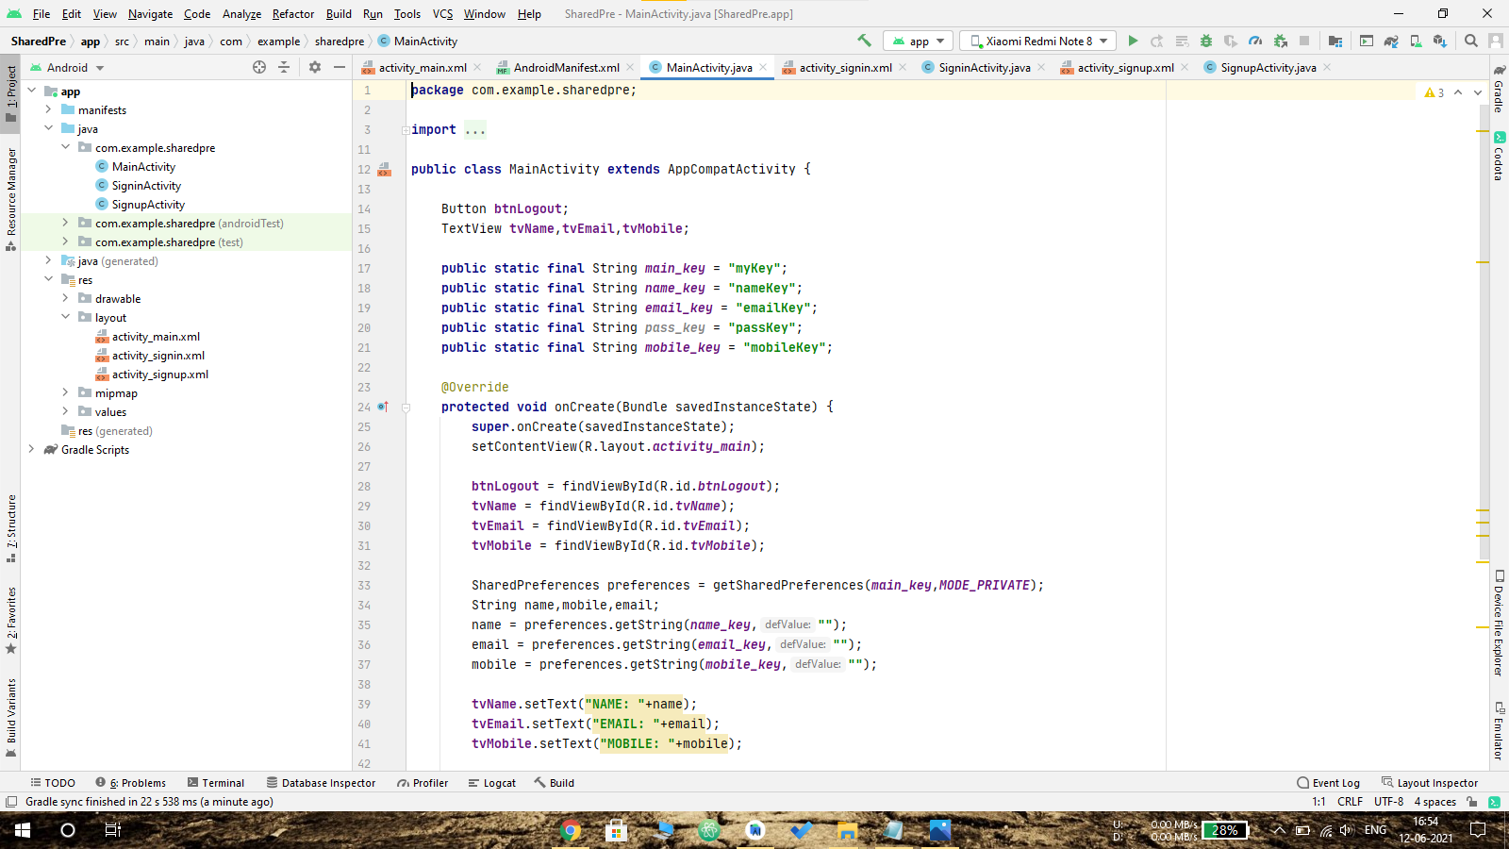

Activity_signup.xml:

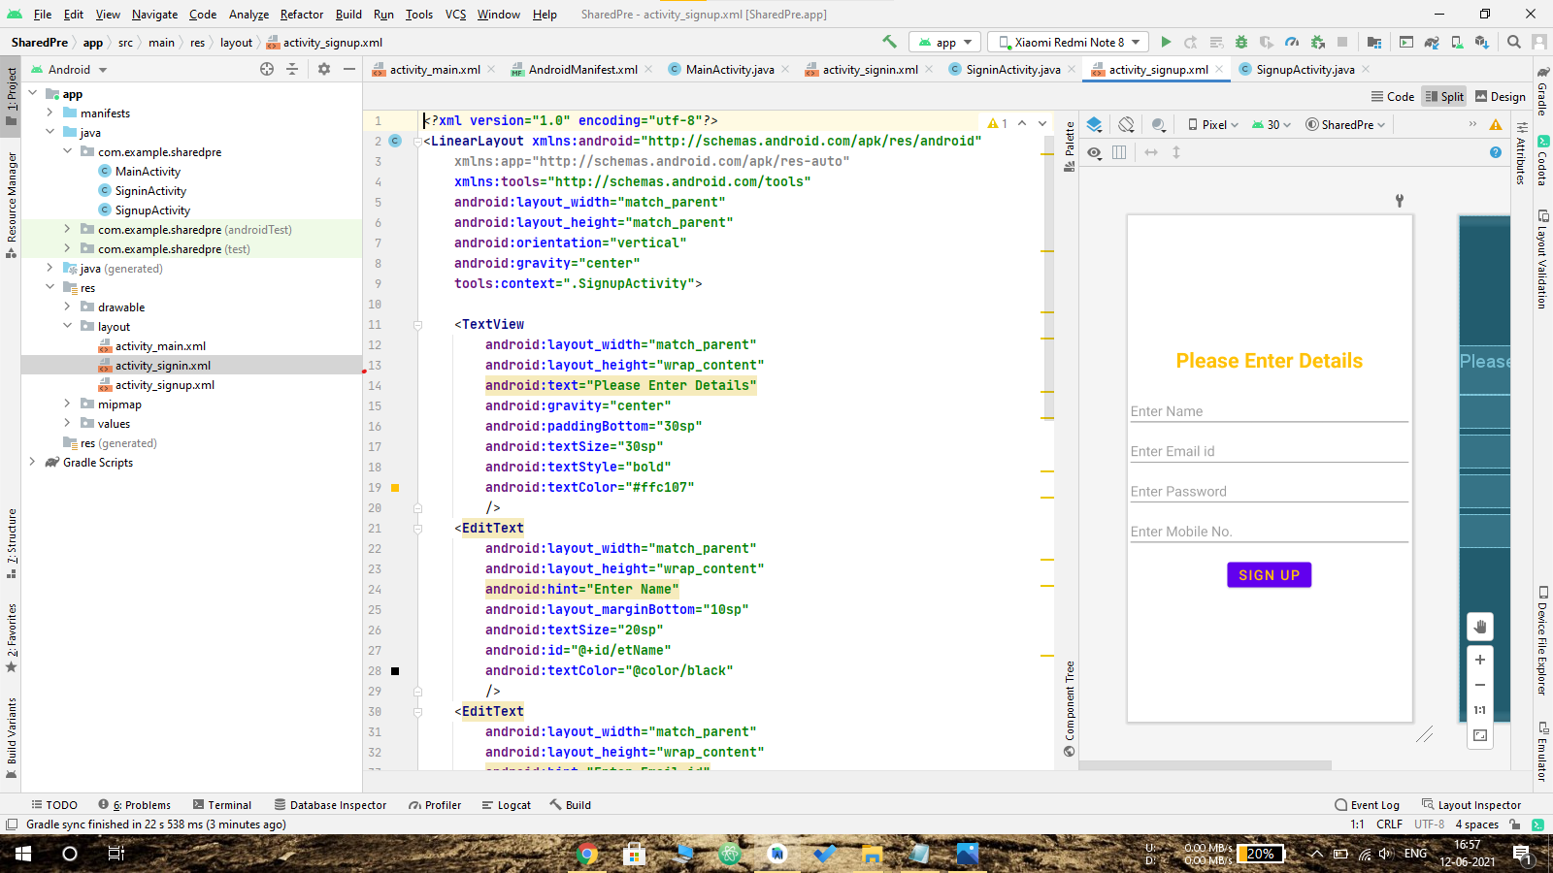

Signin activity.java:

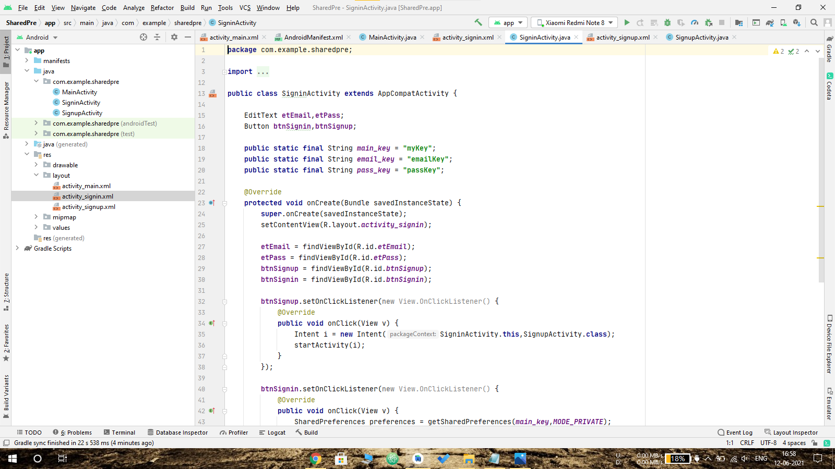

Output:

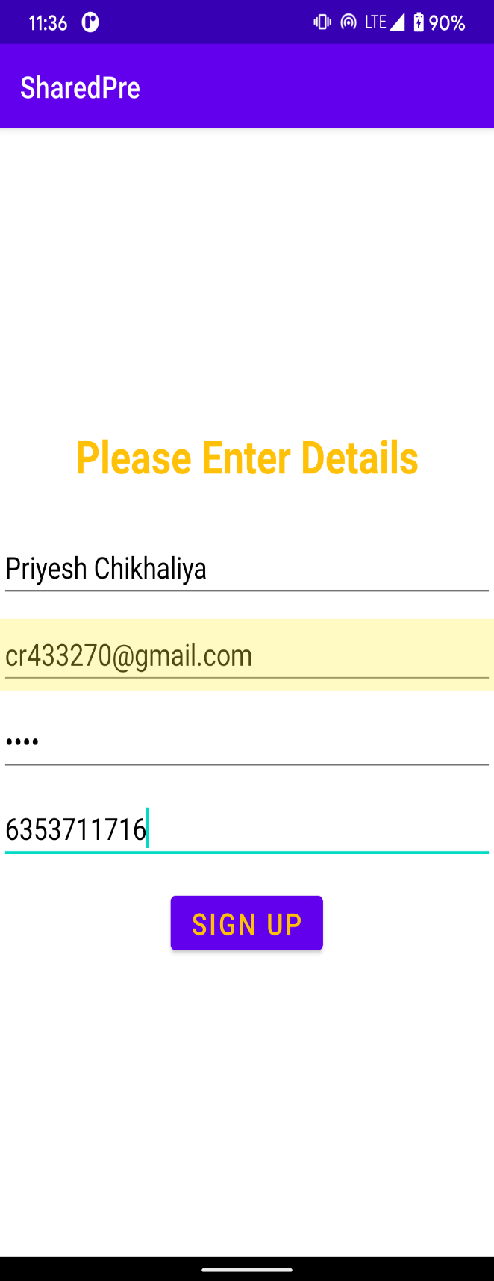

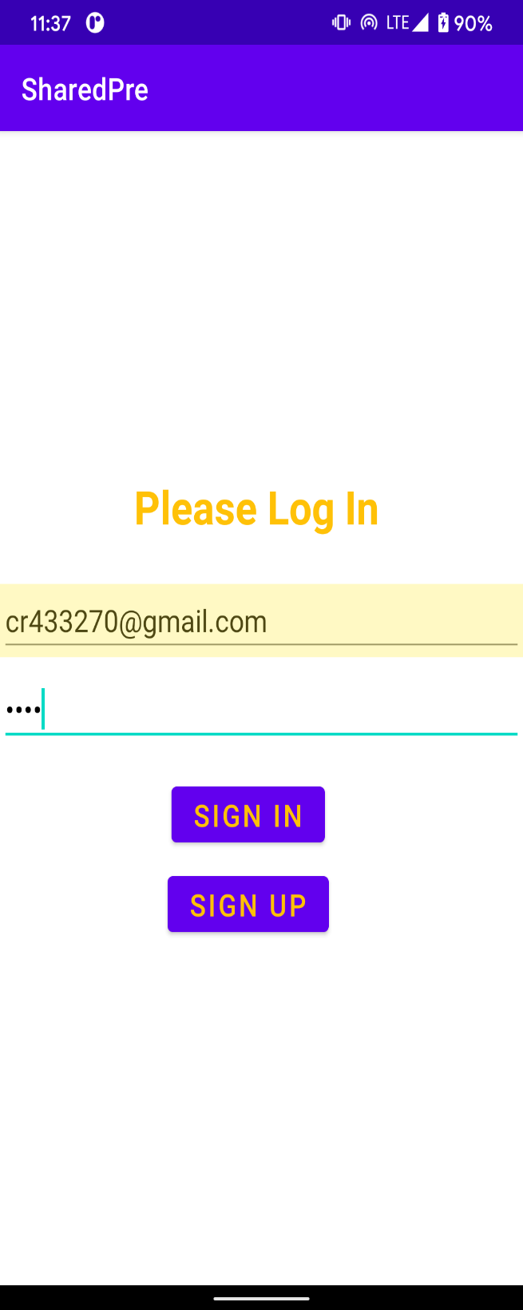 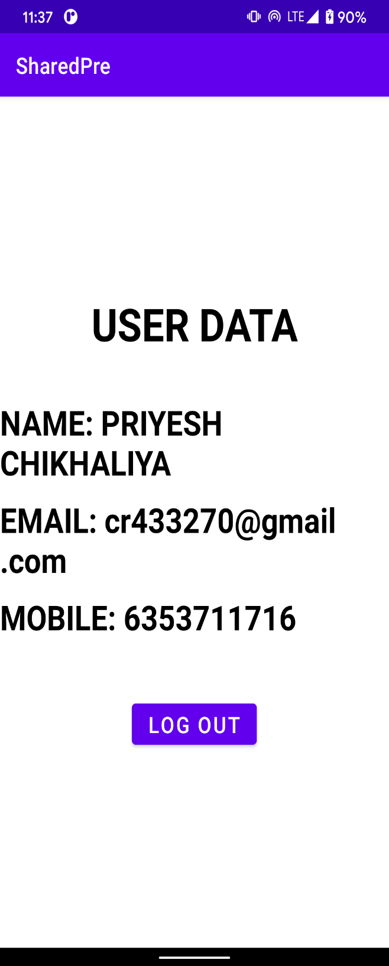

**8 - Phone:**

Using intent’s ACTION_CALL property we can make call from calling app.

**Intent intent = new Intent(Intent.ACTION_CALL);**

We have to set the mobile number to URI and it redirect to calling app.

**intent.setData(Uri.parse("number:"+phNumber));**

and we have to add “uses-permission” for call_phone in AndroidManifest.xml file:

**<uses-permission android:name="android.permission.CALL_PHONE"></uses-permission>**

**Code:**

Main activity:

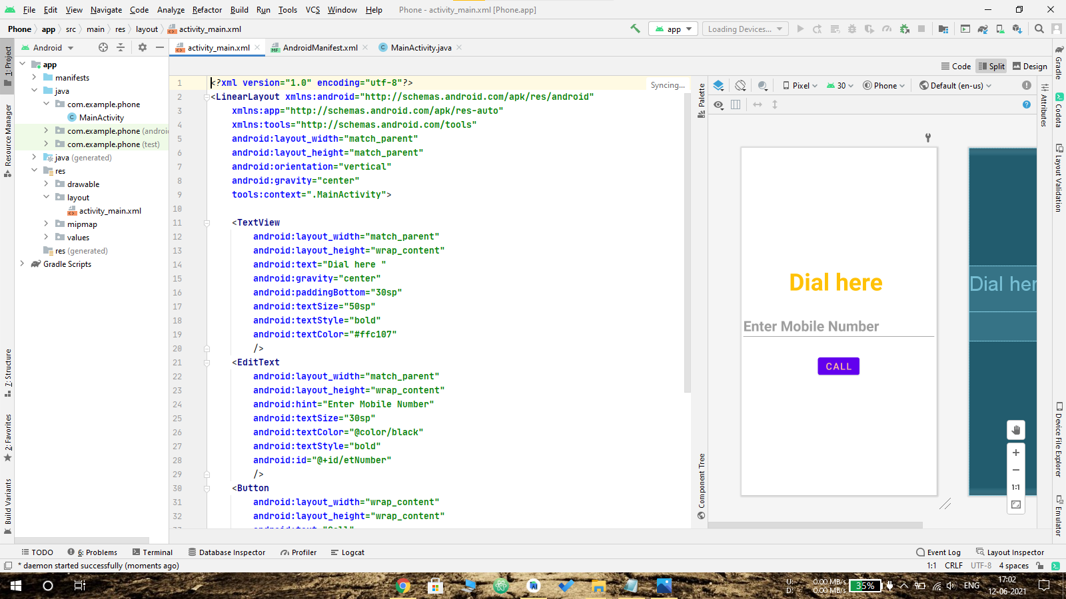

Activity_main.xml:



Output:

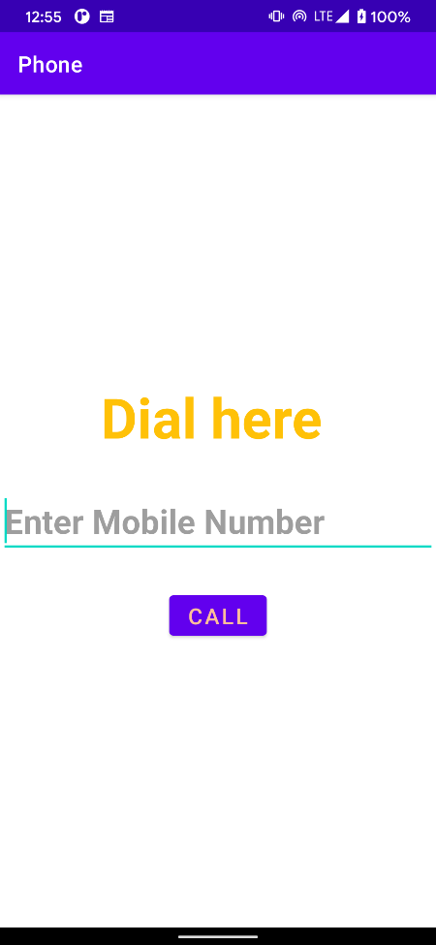

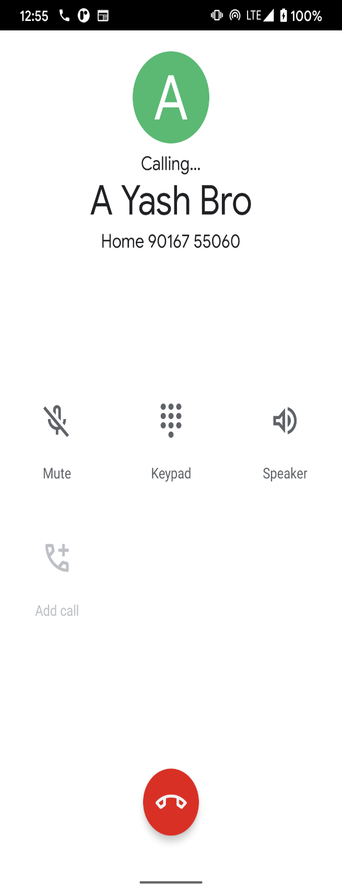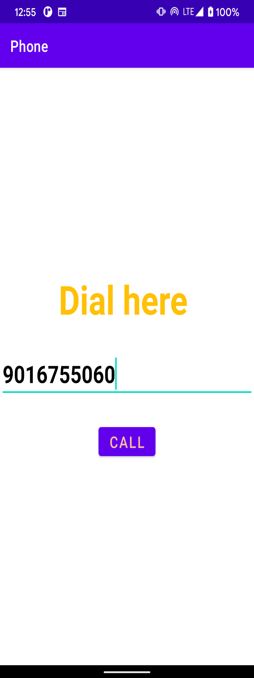

**9 – PostOffice:**

To send email from our android application we need following Intent actions. **Intent.ACTION_SEND, Intent.EXTRA_EMAIL, Intent.EXTRA_SUBJECT, Intent.EXTRA_TEXT, Intent.createChooser().**

**Code:**

Main activity:

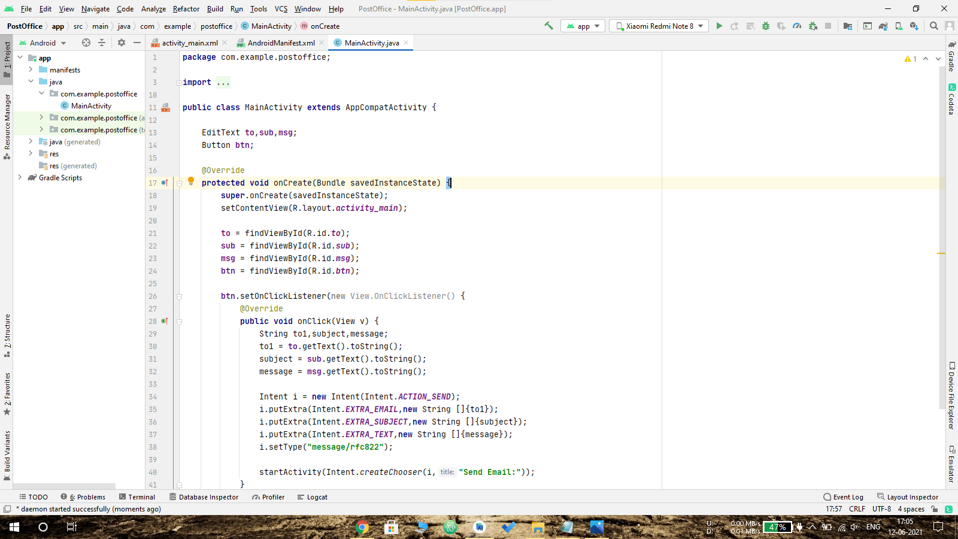

Activity_main.xml:

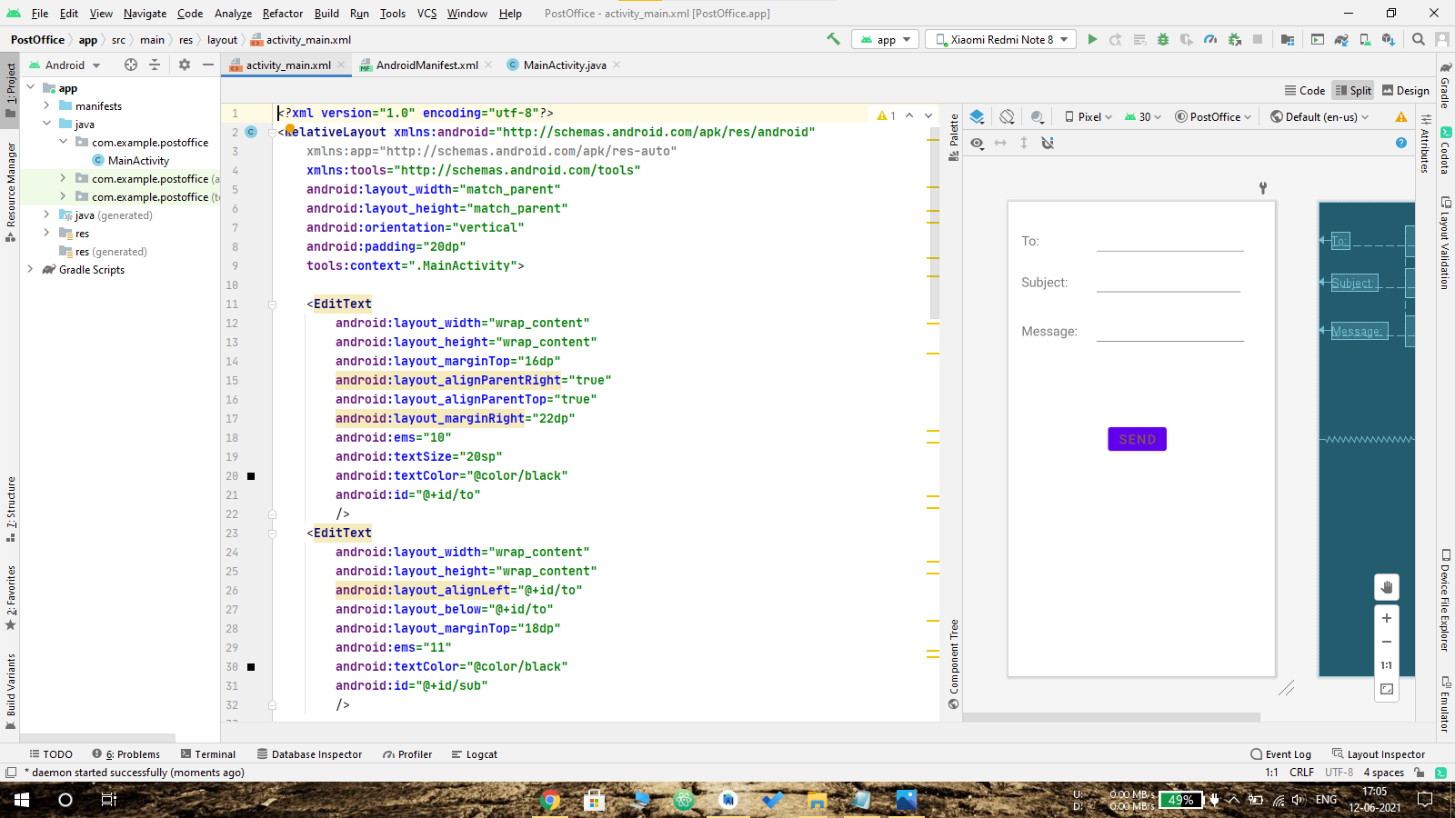

Output:

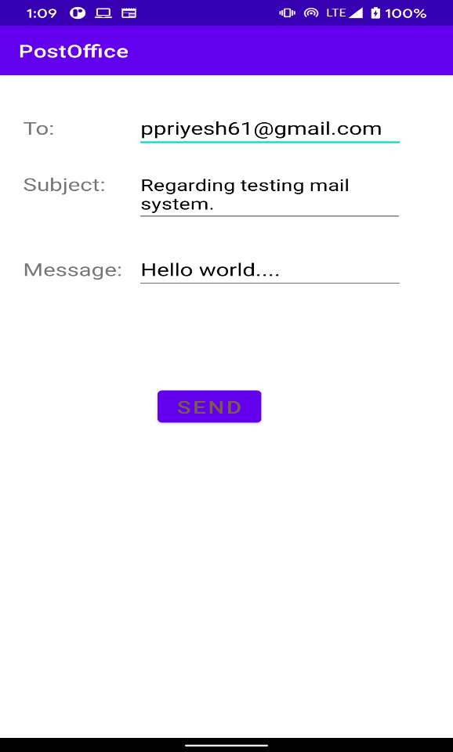 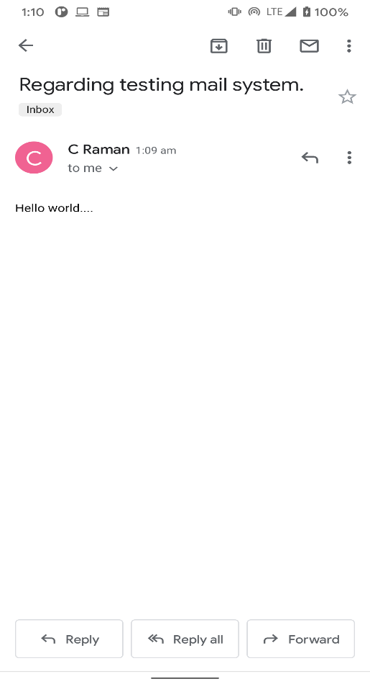

**10 – Message:**

* We can send SMS from our android application in two ways either by using SMSManager api or Intents based on our requirements.
* If we use SMSManager api, it will directly send SMS from our application.
* In case if we use Intent with proper action (ACTION_VIEW), it will invoke built-in SMS app to send SMS from our application

**Code:**

Main activity:

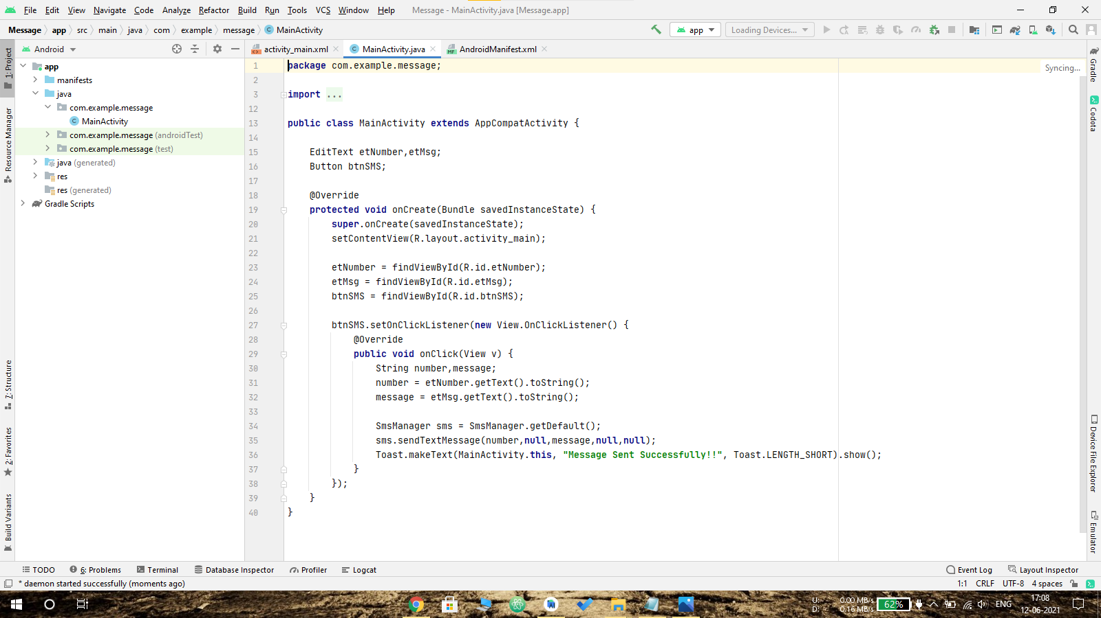

Activity_main.xml:

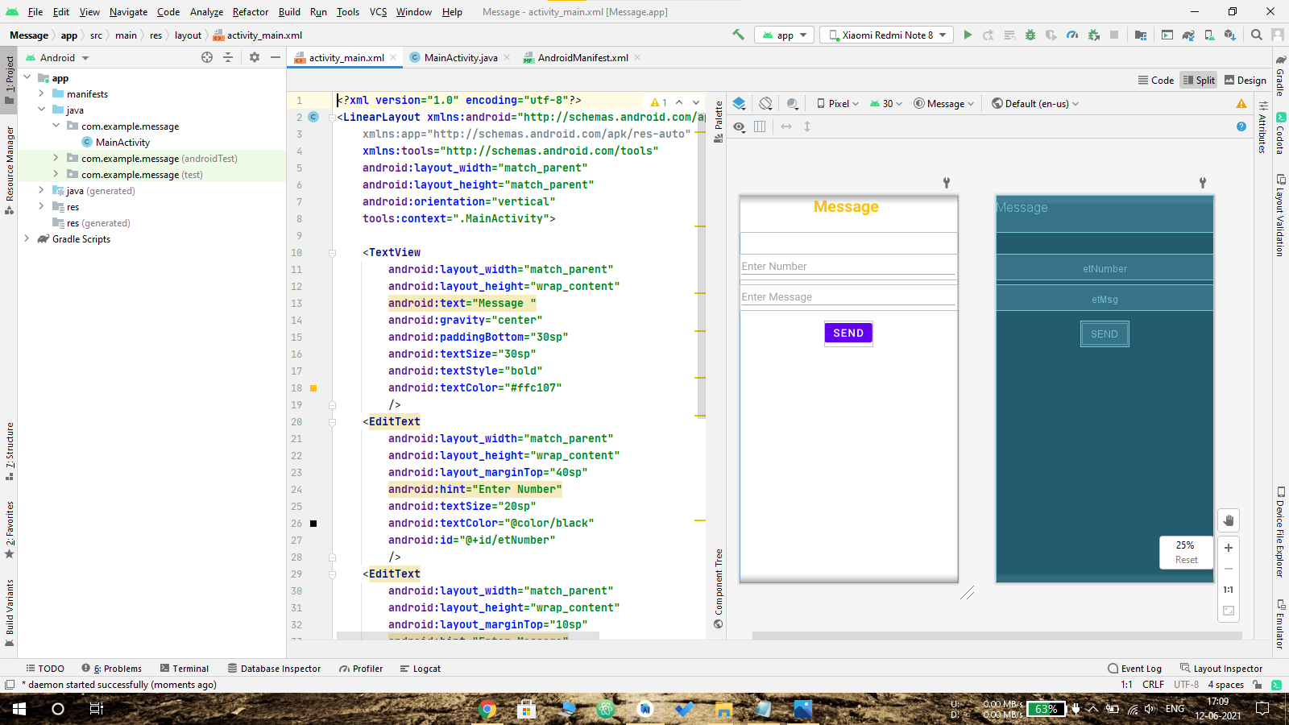

Output:

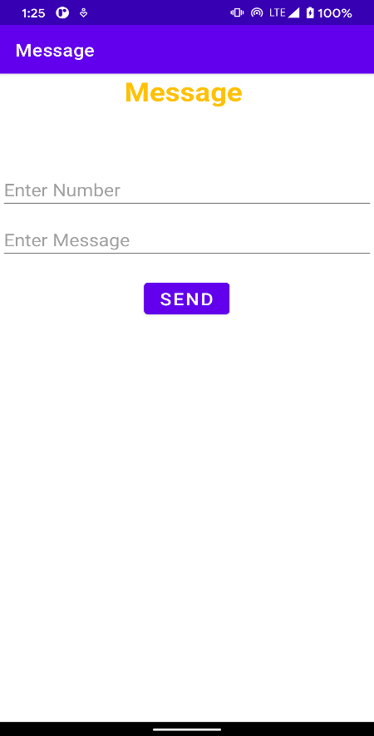 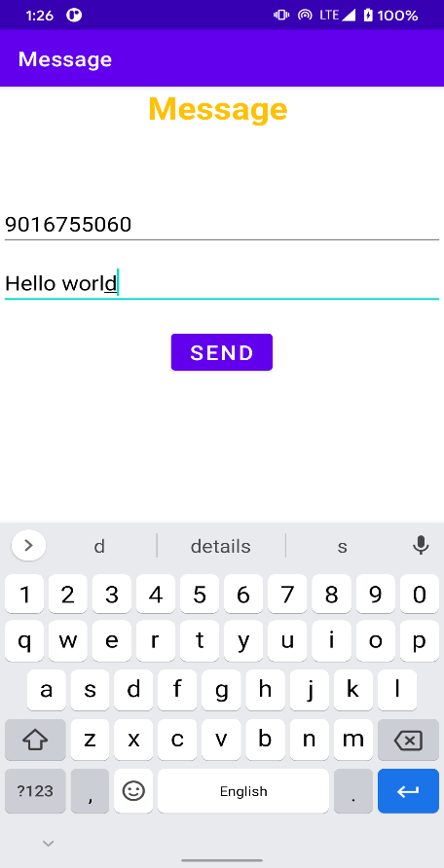

**11 –Player**

To Play music we have to define MediaPlayer:

**MediaPlayer mPlayer = MediaPlayer.create(this, R.raw.audio_file_name);**

After that We can start Media Player using start() Method.

**mPlayer.start();**

**pause()** method is used to pause the Audio.

**stop()** method is used to stop the Audio.

**Code:**

Main activity:

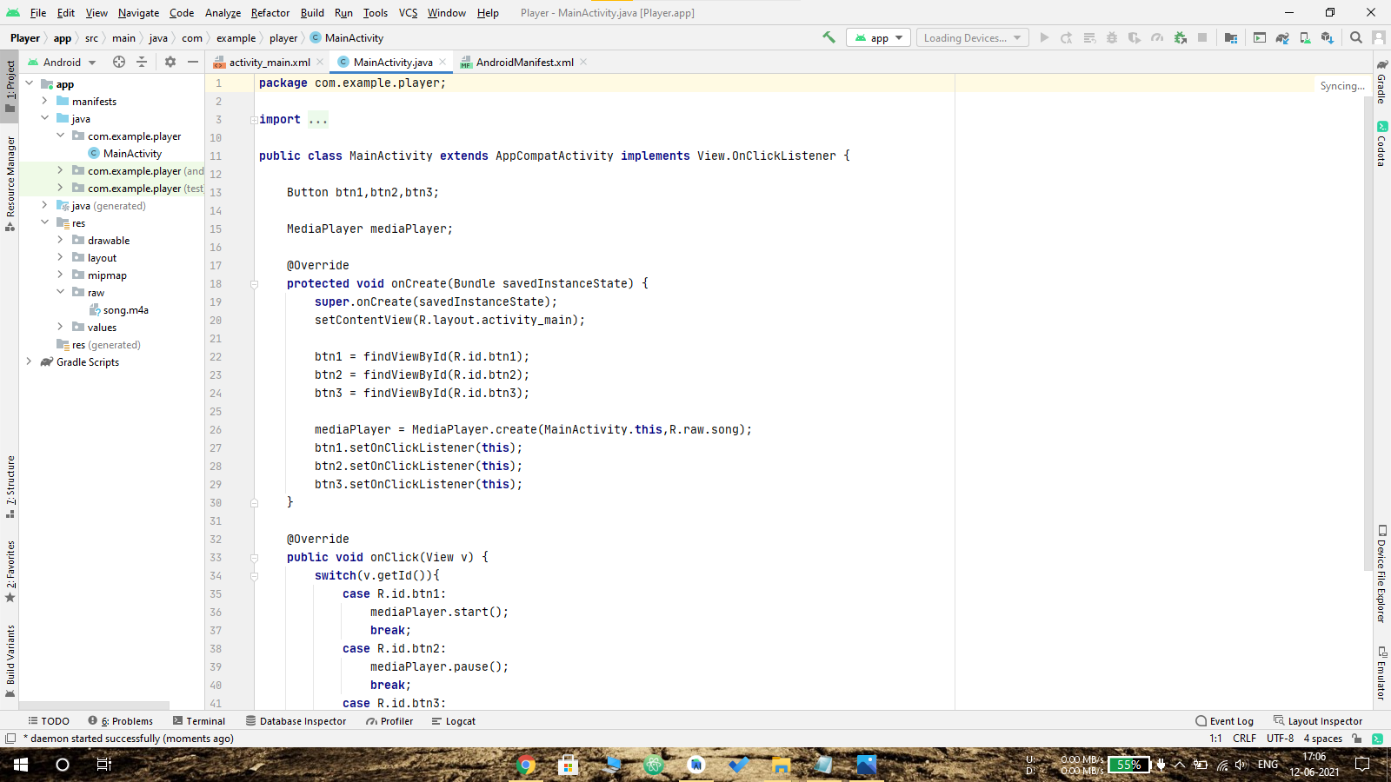

Activity_main.xml:

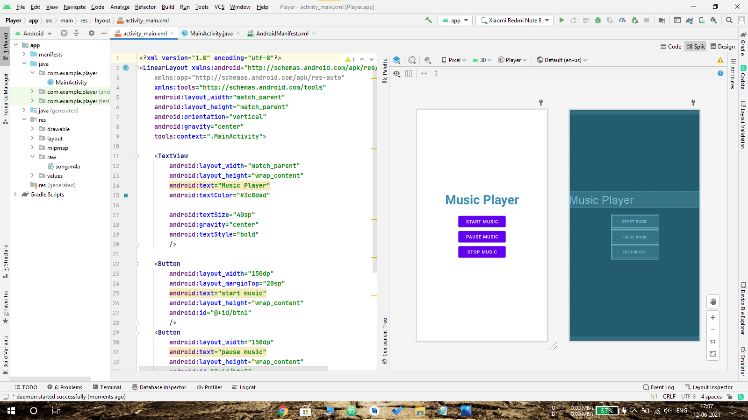

Output:

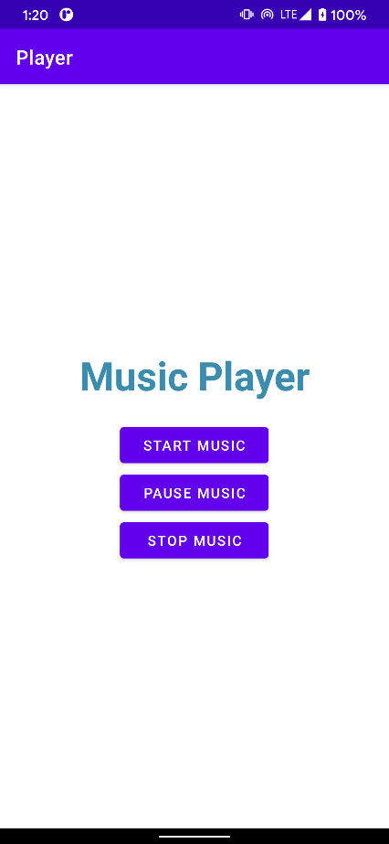

**12 – Binge:**

In android , VideoView component and MediaController class is used to implement the video player in android applications to play the videos with multiple playback options, such as play, pause, forward, backward, etc.

**Code:**

Main activity:

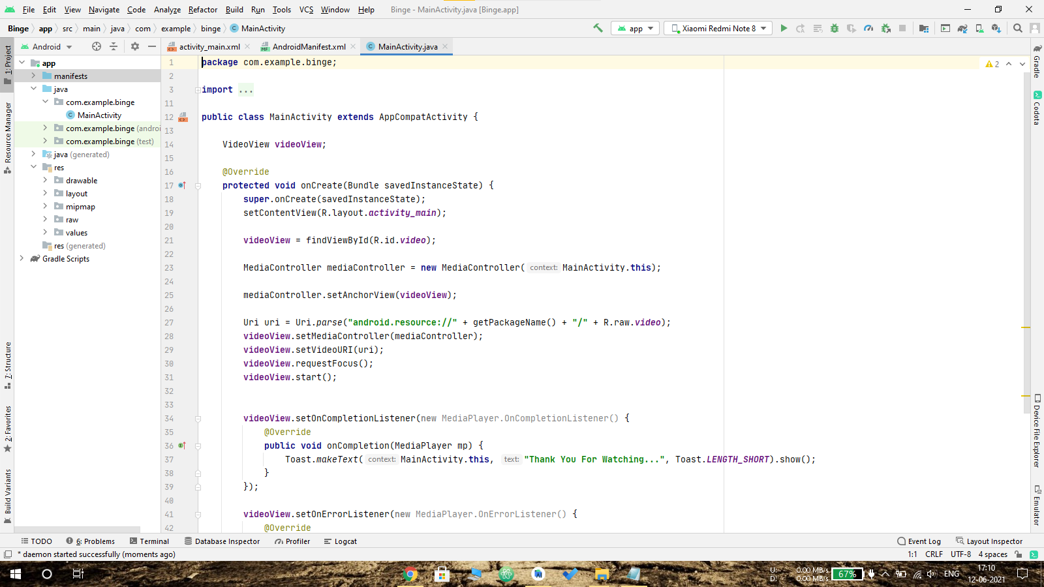

Activity_main.xml:

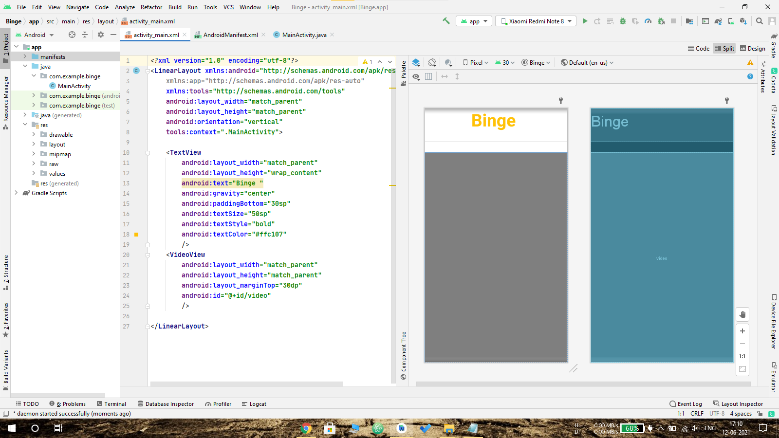

Output:

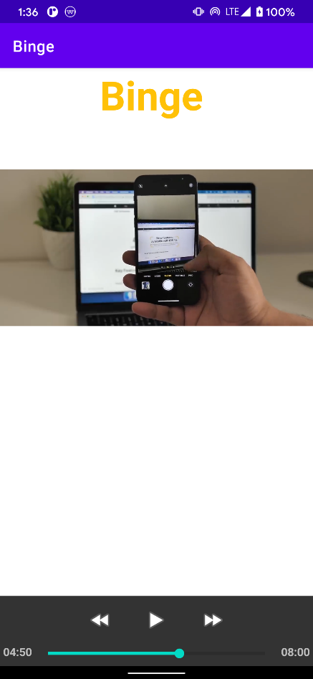

**Project**

**Video Player app-master:**

In this it List all .mp4 files from internal Storage and we can play video of our choice in Landscape Mode.

**Code:**

Main activity:

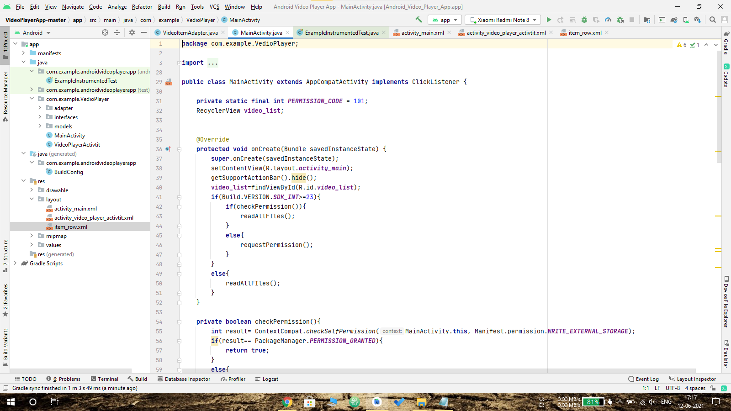

Activity_main.xml:  
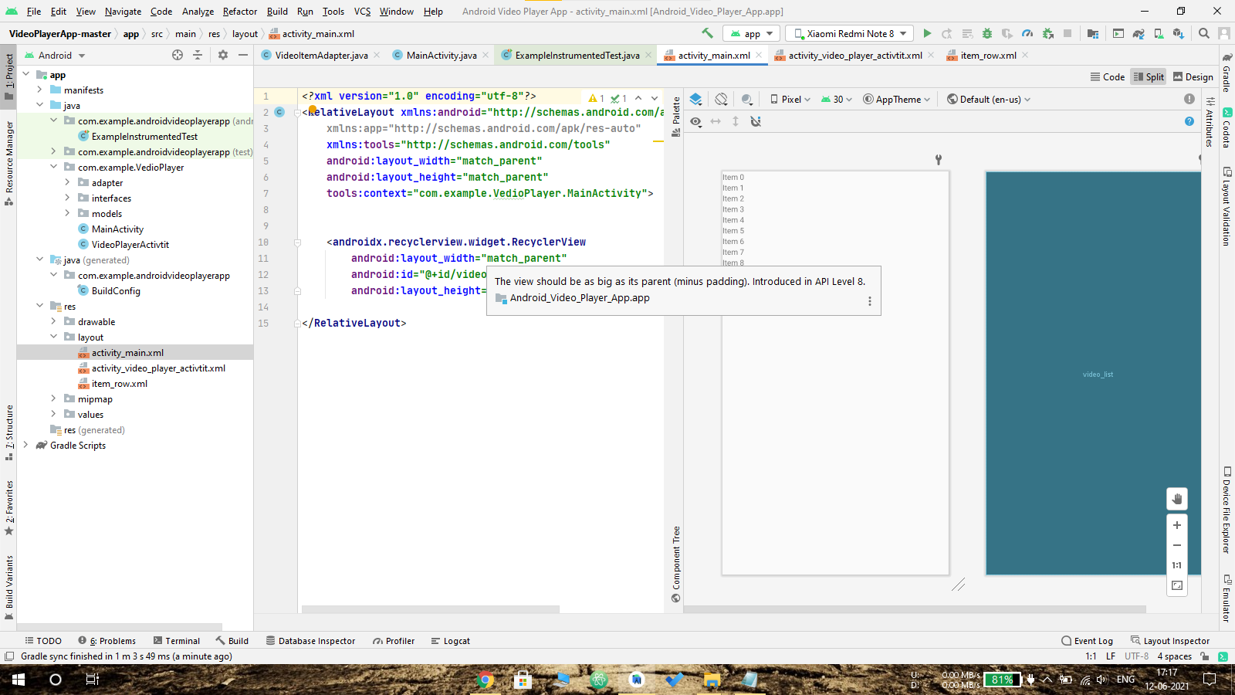

Activity_video_player_activeit.xml:

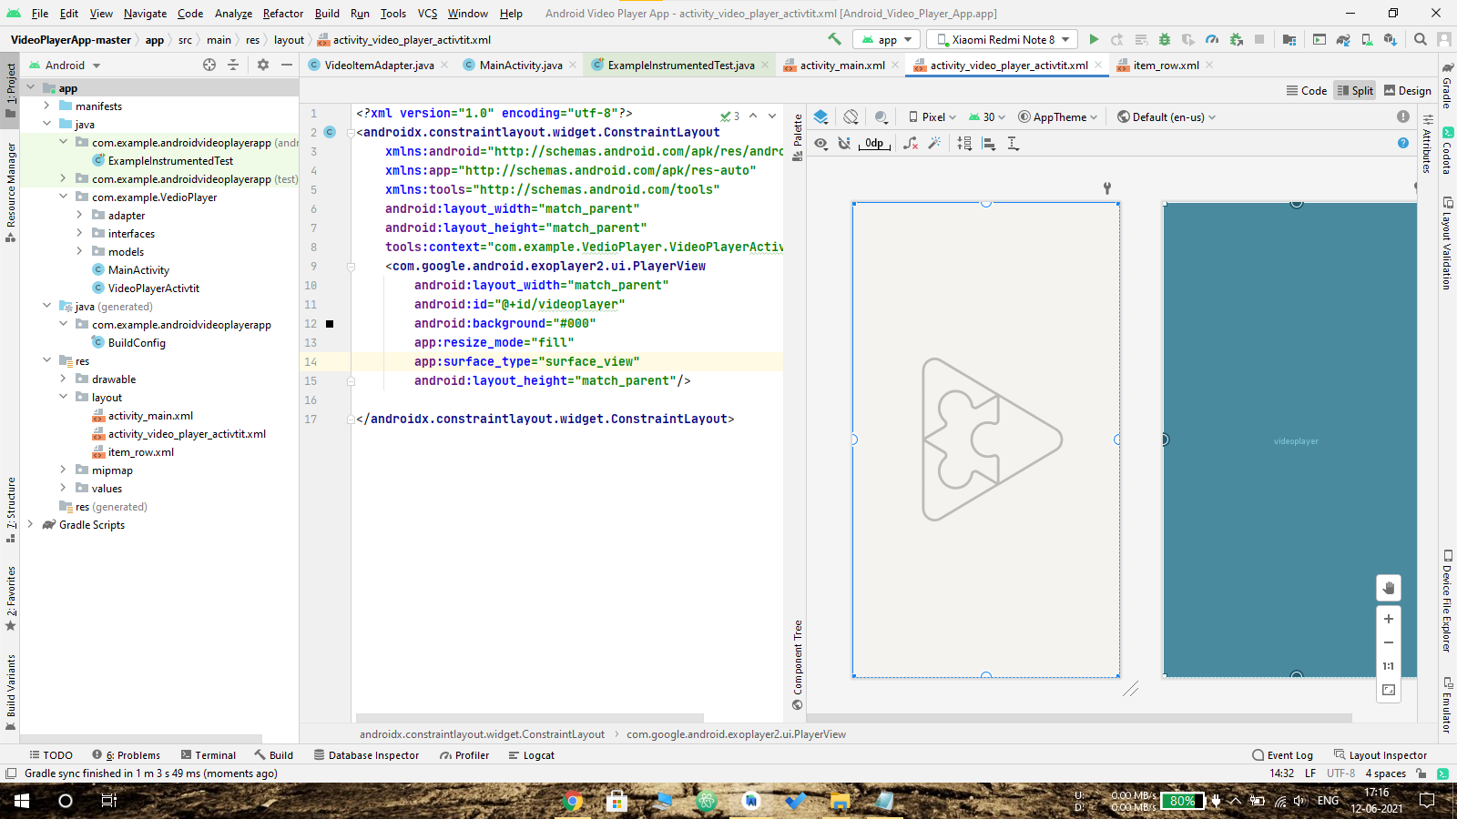

Item_row.xml:

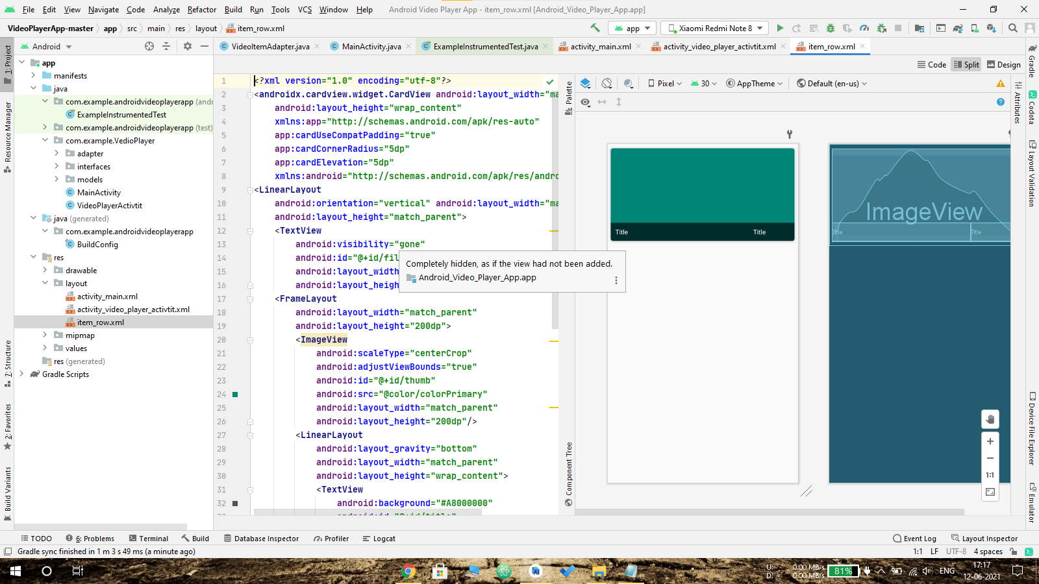

VideoItemAdapter.java:

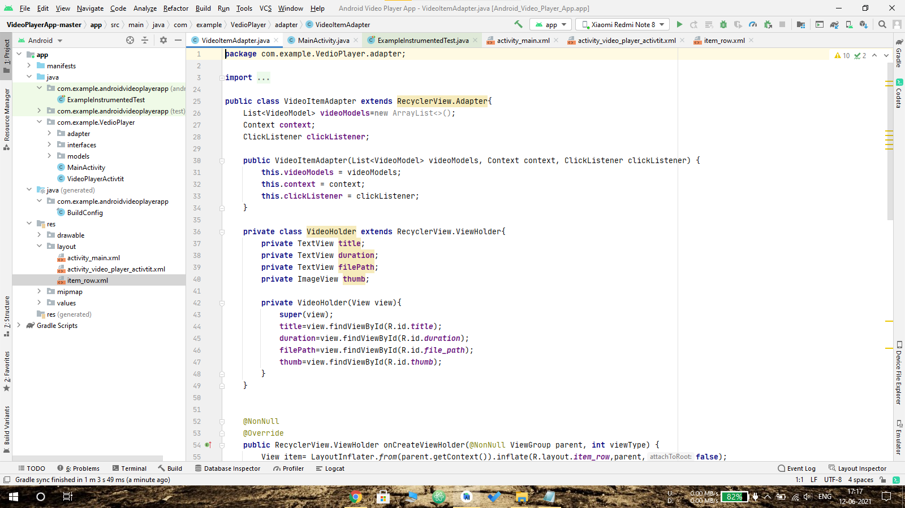

Output:

